CONTENT
Chapter 1 Safety 2
1 Precautions for safety 2
1-1 Precautions for safety 2
1-2 Label of warning 2
2 Safety device 3
2-1 Detailed rules 3
Chapter 2 General 4
1 Outline of mechanism 4
1-1 Purpose of use 4
1-2 Main technical parameters 4
1-3 accessories with the machine 5
1-4 Outlook drawing 5
1 Set-up 7
1-1 Way of set-up and flow sequence 7
1-2 The place and conditions where the machine is placed 8
2 Operation 9
2-1 Flow of cutting 9
Take a test of cutting upon the following flow at the initial use. 9
2-2 Operation panel and Liquid crystal display explanation 10
2-3 Datum selection 16
2-4utting mode 17
2-5 Parameters set of instructions 32
2-6 Operation method and process 32
⑴ Input power 32
2-7 The longitudinal cutting knife assembly loading and unloading methods 34
3 Troubleshooting 35
3-2 Way to settle the warning 38

Chapter 1 Safety
To prevent accidents and dangers from happening, the operators are required to get familiar to the precautions of safety and completely understand the content therein before set-up, operation, check and maintenance.

1 Precautions for safety

1-1 Precautions for safety
To prevent any accidents, please follow the precautions below strictly.
(1) Have the ground-wire of the power supply well grounded.
(2) In case of a long hair with the operator, please tie it when to operate the machine in order to avoid being rolled into it.
(3) Do not touch the electric points and the loops with wet hand.
(4) When stop to use of the machine, please cut off the power.
(5) In case of an abnormality with the machine, cut off the power directly.
(6) Please contact with the dealer when there is any question about the way of
operation or work.
(7) In case of a failure with the machine, please contact with the dealer, if it is no way to settle upon the way noted therein.

1-2 Label of warning
Operators are required to pay special attention to the places fitted with the warning labels during operation, check and maintenance. Description of the warn labels
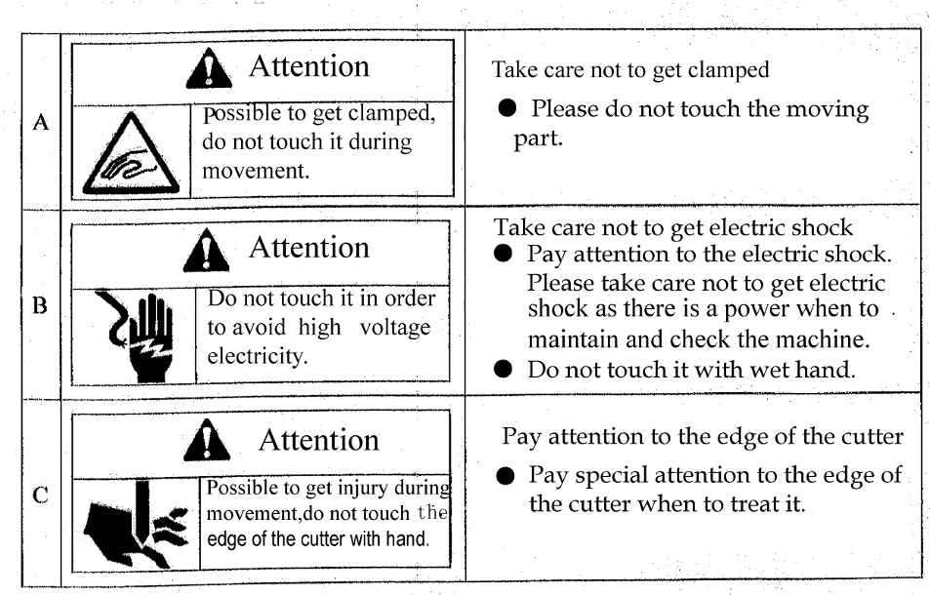

2 Safety device
To prevent accidents and dangers, safety devices are set on the positions for the operator to be possible to touch.

2-1 Detailed rules
Detailed rules and operation limit.
Both fixing and lock covers are set to prevent any tools and clothes from being rolled into the machine due to carelessness of the operator.
Never do operation when the covers are opened. Once the lock cover is opened, the machine will stop moving right away.
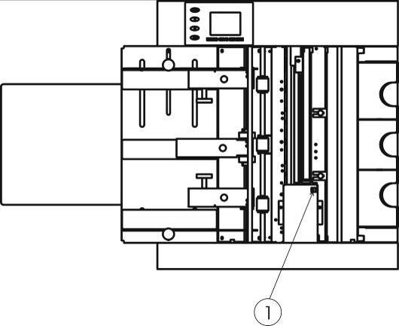 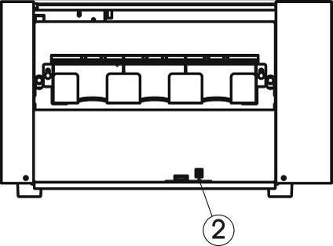 Top head switch Paper scraps box switch

Chapter 2 General
In this chapter, the information related to “card cutting machine” is recorded.

1 Outline of mechanism

1-1 Purpose of use
To have the printed name cards or photos automatically cut into the suitable sizes.

1-2 Main technical parameters
Way of cutting | Longitudinal: rolled cutting by a roller; horizontal: cutting by a lateral long cutter
Way of paper feeding | Automatic paper feeding in single rubbing way
Size of paper | A4(210mm*297mm)/A3(297*4200mm)/A3+(320*480mm)
Thicknes of paper | 0.20mm(180g/m²---0.30mm(350g/m²)
Paper nature | Common paper, quality paper
Cutting speed | For name cards, about 100pcs/min
Cutting size | Longitudinal: 55（or 54）mm and 89(or 85，90，95)mm;Horizontal: 40-250mm, adjustable
Volume of paper | Maximum 12pcs (about 0.25mm thick) for name cards or total thic
Volume of name card | 180g/m² 150×5pcs 350g/m² 110×5pcs
Mechanical dimension | 510mm×305mm×755mm
Ambience of use | -15℃～+40℃ humidity 35%～70%
Weight | About 35Kg
Power supply | AC 90--240V，50/60HZ,1.0A

1-3 accessories with the machine
Please confirm the accessories below at unpacking.
No. | Item | Quantity | Remark
1 | Instruction | 1
2 | Feeding paper lengthen board | 1
3 | Power line | 1
4 | 5-column longitudinal knife assembly | 1 | 55mm
5 | 5-column name card case | 1

1-4 Outlook drawing
Outlook drawing
Chart—1 Front drawing
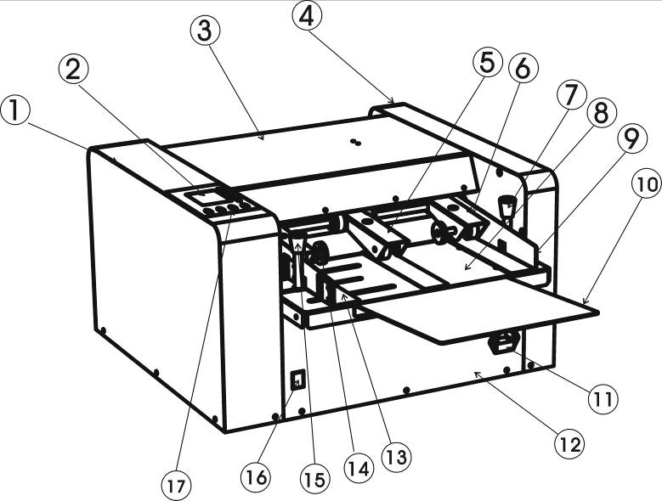

Left outer covering Display monitor(Touchscreen) upper cover right-side cover Middle paper rubs wheel Right paper rubs wheel right locks the pole Enters the paper platform Right feeding desk Paper carrier Power point frontal cover Left feeding desk Left paper rubs wheel left locks the pole Power switch operation panel
Chart－2 Side view
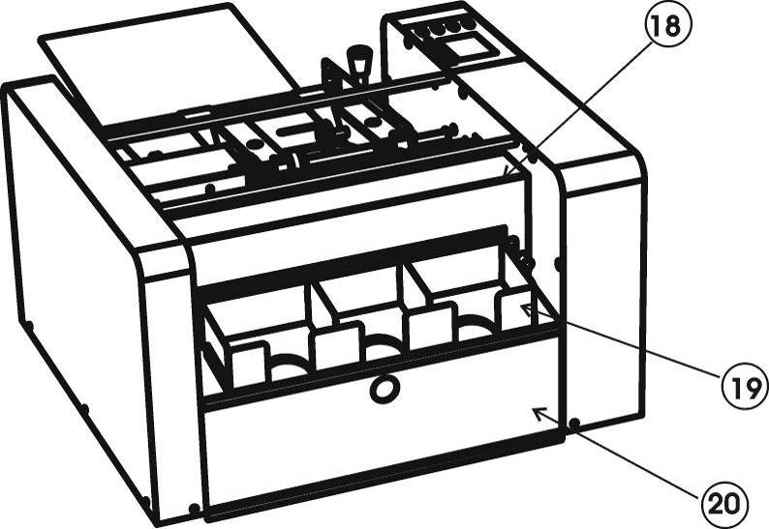
Back cover Business card case1 waste pper collecting case
Chart 3--Overlooking view
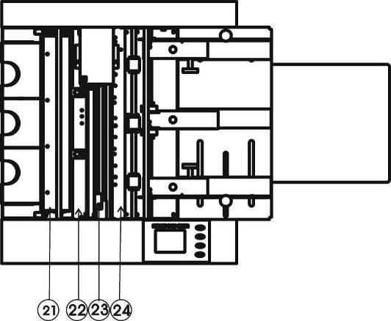
Longitudinal knife Backside Paper feeding module horizontal knife Front paper feeding module
Chapter 3 Set-up, operation and maintenance
In this chapter, the matters related to the machine set-up and the daily work flow is recorded.

1 Set-up

1-1 Way of set-up and flow sequence
⑴ Take the machine out of the package.
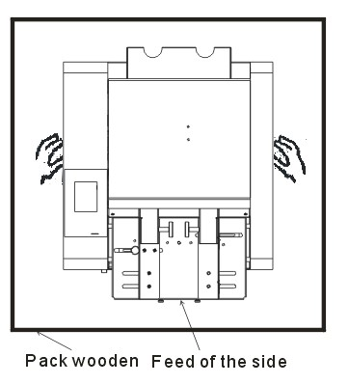
⑵ Place it on a safe, solid, fixed and stable working table.

release both hands at the same time.
- Insert the paper feeding salver into machine, lock the fixed position which on the salver
electric shock may occur in case of an electric leak.
Please make sure of the power switch to be in good connection.

1-2 The place and conditions where the machine is placed
Please use this machine in the place as below:
- Horizontally fixed place

- Well ventilated place
- Leave a proper workable space around the machine.
As this machine is made with a precise mechanism and electronic elements, a failure may occur with it if used in the place as below:
- Direct sunshine
- Mists often happen
- Wetted
- Available with fire
- Easily made wet by water
- Close to a cold-warm house
- Available with vibration
- Please do not have any other plugs inserted in the socket used specially for the machine.
- Use a static-electricity preventing cover and a humidifier for the place where the static electricity happens easily.
- Do not place the machine on a table smaller than itself.

2 Operation

2-1 Flow of cutting

Take a test of cutting upon the following flow at the initial use.
At the end of machine placement

Turn on the power switch

Press [Start] key and after one idle movement, put a printed testing paper on the paper feeding tray

Choose paper pattern(A3,A3+,A4.from definition

Specification choice

Adjust the right-left positions of the paper feeding desk

Cut the testing paper

Accurately cut without

Cutting test finishes

Reset the card selection

2-2 Operation panel and Liquid crystal display explanation
This machine uses the touchscreen operation, with great convenience, only needs the finger click should the position then to adjust. After starting, the screen demonstrated:


Clicks on the screen relevant position, choice language, if does not choose, presses down when automatically a close-down uses the language to enter the initial contact surface.
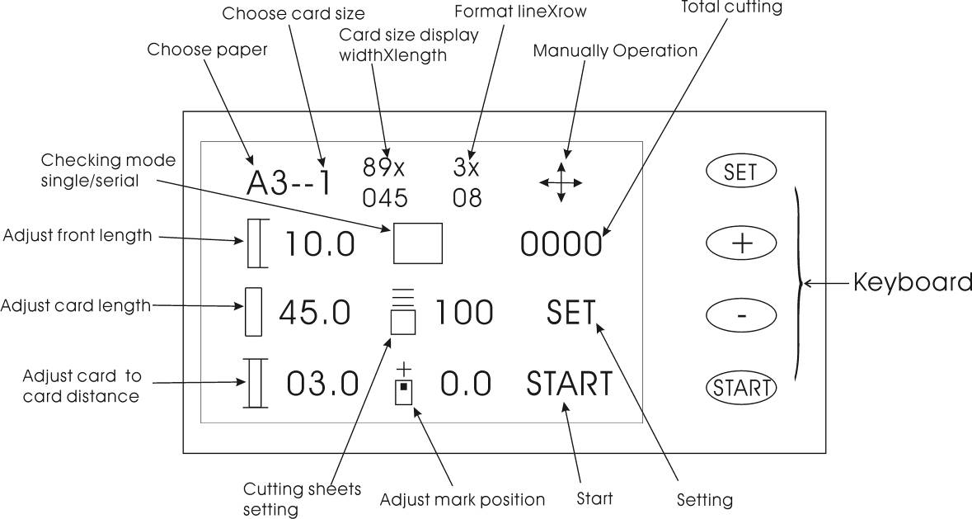
●Chooses the key with the paper: choice paper specification, click here may in A3, A3+, A4, cut from the definition.
●Test way、continuous/single sheet ，click herePlace demonstrated in turn：
Shows:Front examines the single sheet to enter the paper、Front examines enters the paper continuously、The mark detection single sheet enters the paper、The mark detection enters the paper continuously。

●Front length adjustment、Card length adjustment、Middle leaves the filings adjustment，Clicks on the relevant position, screen Right flank demonstrates the following chart：Presses increases the key（Or keyboard “+” key）、Reduces the key（Or keyboard“－”key）Adjustment，If must restore to the system default value click “the restoration” the key，The adjustment completes presses “confirms” the withdrawal。When adjustment card length confirmation，In card size demonstration place，the card length along with it change。As photo，When the card length adjustment is “46.0”, then card size demonstration place demonstration: “89x046”, here decimal digits did not demonstrate.
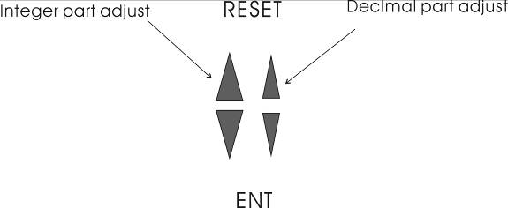
●Set numbers of cutter paper and then clikc the screen right side,will appear like this photo，Presses the corresponding key adjustment, completes presses “confirmed that” the key withdraws, Remark: This hypothesis dinking die card quantity.
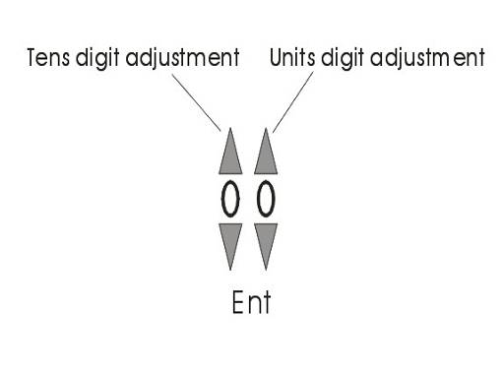
under continuously enters paper way，rach cutting paper，here value then subtracts the cutting card quantity，after cutting completes the machine automatic stopping.
●To mark position adjustment，Under mark detection way，when cutting place not fit close printingplace,please adjust here,press the screen which appear downward or the downward arrow，or press the keyboard on increases or reduces key,the adjustment completes presses confirmed that the key withdraws，above this icon “+” or “-”，on behalf of adjustment value plus and minus.Adjusts this parameter to have an effect to all specifications.
●Start/STRAT key，please click"start" on the screen or press start key on the keyboard enter automatic cutting condition,when in the automatic condition,in the right side screen will appear:
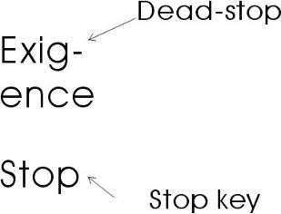
If has the emergency case, please press “stops the key anxiously”，and then it will stop in time,If there is a paper in the internal,Please click ""manual operation manual mode button to enter according to" manual refund paper "will paper exit;if under the continuous work way,press "stop"key,heard "drop" tip sound and take away finger,This paper completely after cutting and stop;Then press the "start" button is still according to "count function" is shown on the remaining number of sheets work, when "count function" showing that the number of "000" will be automatically stop.
●Set key, click "Settings", the parameters set, the screen as shown below：

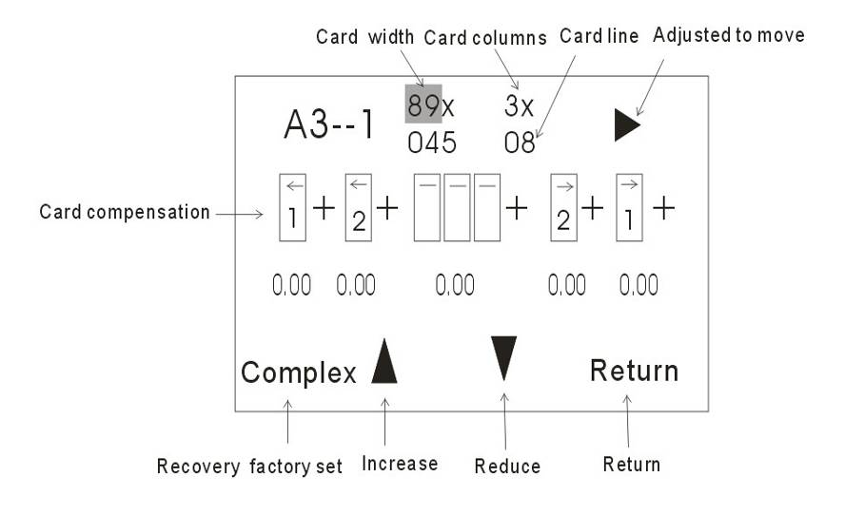
(1) “A3—1”，Said the current specification and paper cutting specifications of the serial number, can not be adjusted.
(2)“89”，Card width, according to the width of the longitudinal cutting adjust the numerical values, such as the longitudinal cutting knife width is "90 MM," here is changed to "90", the only that a function, to the actual cutting no effect.
(3) “3”,Card columns, according to the longitudinal cutting knife used column number adjustment, such as the longitudinal cutting knife columns for "5", here is changed to "5", the play that role, mainly used for calculation of the cutting number of sheets, and the cutting no effect.
(4) “08”Card rows, used for setting the cutting line number of cards.
(5)  Adjustment of mode, click here to switch to adjust the item, the item to adjust to the shadow show, such as the "89" place for is to adjust the item.
(6)Card compensation, when cutting out the size and size have set when difference, we need to adjust the item.

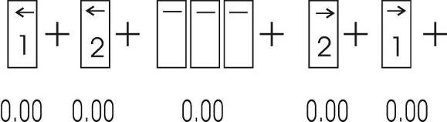
as follows: the first card compensation, the second card compensation, middle card compensation, in the second card compensation, reciprocal first a card compensation.Subsequent "+" says the value of the symbol adjustment，“-”says compensation quantity to reduce ，unit“MM”，adjust the amount of variation“0.05MM”。Card number of sheets (line number) and compensation amount of corresponding relation as below.
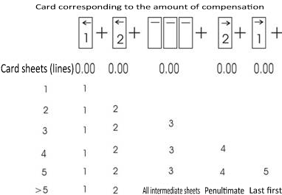
（7）"Complex", click here to this page to restore all the parameters set factory.
(8),the key of Numerical increment, reduce.
(9) "Return", click on exit parameters set interface, data storage。
● “0000”,appear total cutting number of sheets, users can't usa any more can return to "0".
●Manual operation key: when there is need to manually operation such as paper jam please click this button,right side of screen will appear below:
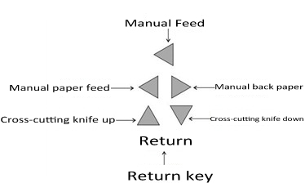
Click on the screen is corresponding key operation is completed, press "back" button to initial interface.
(2) Protection function
This machine is equipped with two kinds of protection function，See "2-1" explanatio,in the initial interface，such as open"up cover:or pull out"wast paper box"，press the key of "start"，The screen prompt "cover open" / "box pulling" with"drop...drop..."alarm sound till "up cover"cover/"waste paper box"promoting alarm lifted. Press the "start" button to work properly;in automatic cutting paper such as "up cover" open or "waste paper box" pull, machine will stop after complete actio,have the same alarm sound with up and show, "up cover" cover / "waste paper box " promoting and then normal work, won't produce waste Cards.

2-3 Datum selection

2-3-1 Two selections of datum
1) Frontal end: take the utmost frontal end of the paper as the datum for cutting;
2）Mark■: take the pre-printed mark as the datum for cutting

2-3-2 Printing condition with the paper mark■
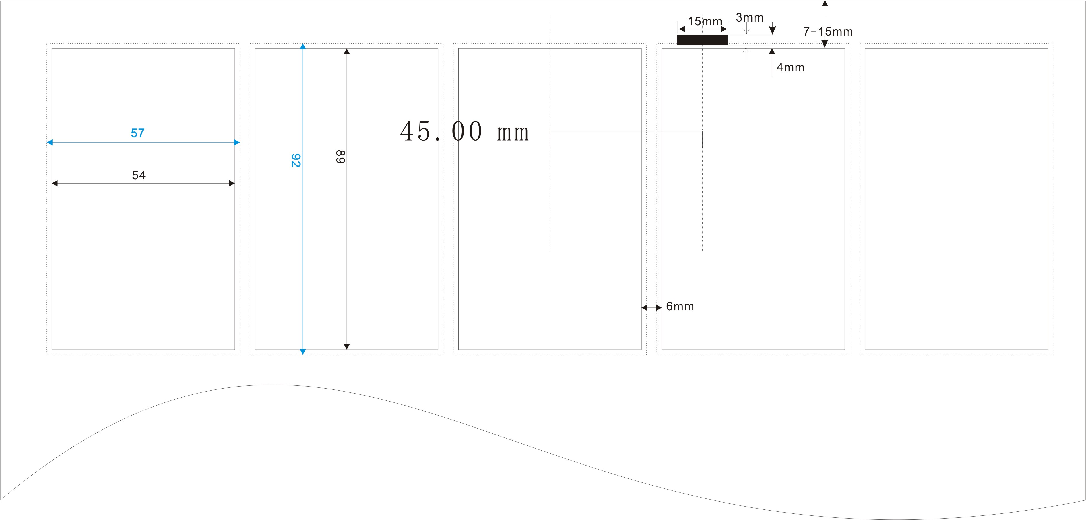

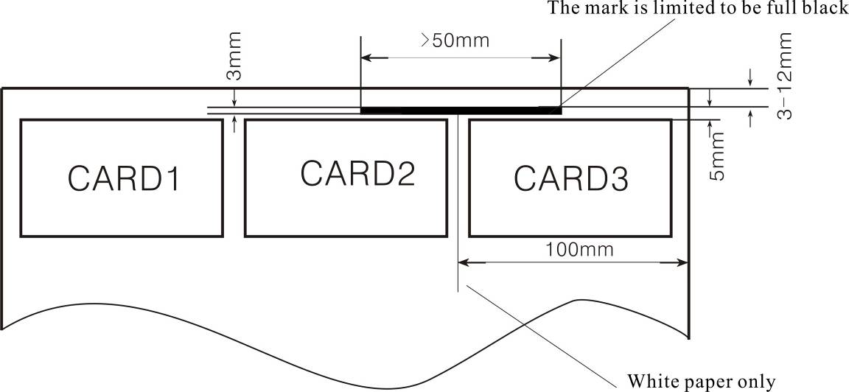

2-4utting mode
It has several cutting mode,please based on function to using.

2-4-1: Paper size：A3+（320*480mm）
A3+--1：89×45mm, use 3-89 rotating cutter group, 3 columns 9 rows total 27 cards;
A3+--2：89×50mm, use 3-89 rotating cutter group, 3 columns 8 rows total 24 cards;
A3+--3：89×54mm, use 3-89 rotating cutter group, 3 columns 8 rows total 24 cards;
A3+--4：89×90mm, use 3-89 rotating cutter group, 3 columns 5 rows total 15 cards;
A3+--5：55×85mm, use 5-55 rotating cutter group,5 columns 5 rows total 25 cards;
A3+--6：55×89mm, use 5-55 rotating cutter group, 5 columns 5 rows total 25 cards;
A3+--7：55×90mm, use 5-55 rotating cutter group, 5 columns 5 rows total 25 cards;
A3+--8：spare.
A3+(320*480mm)Typesetting format figure：

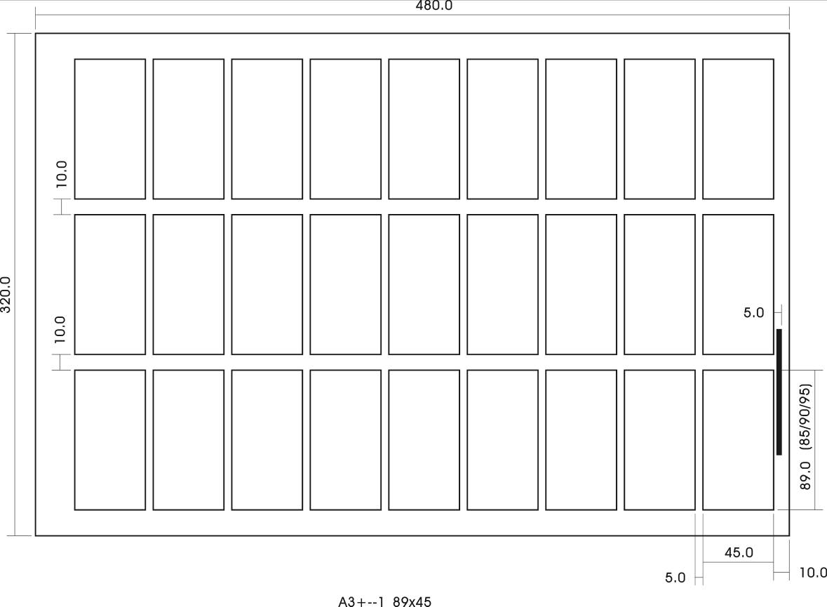

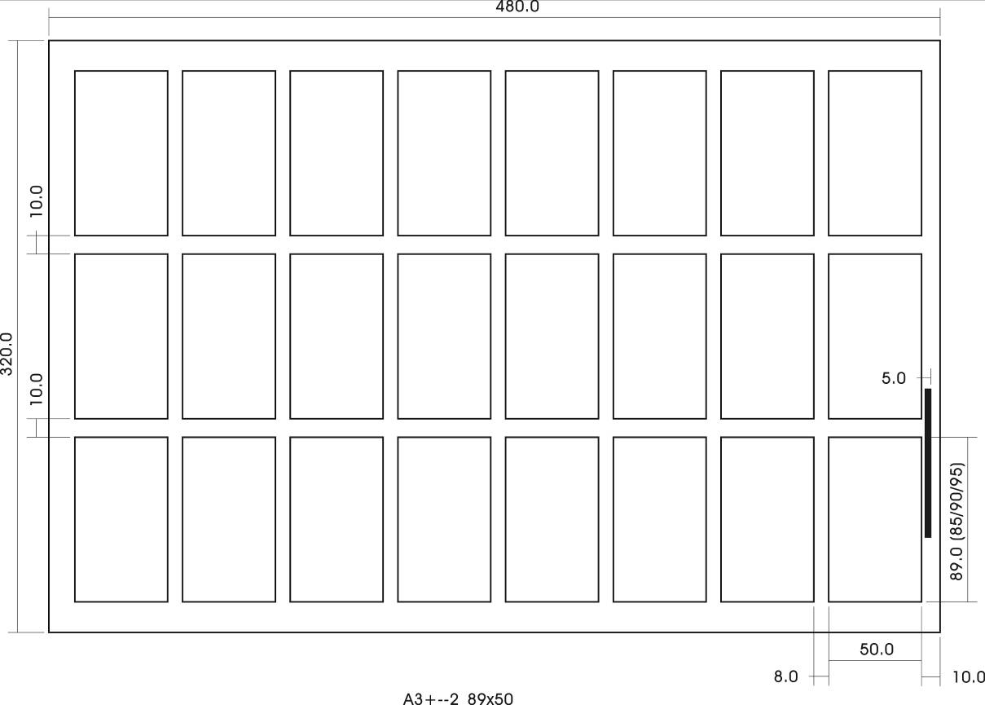
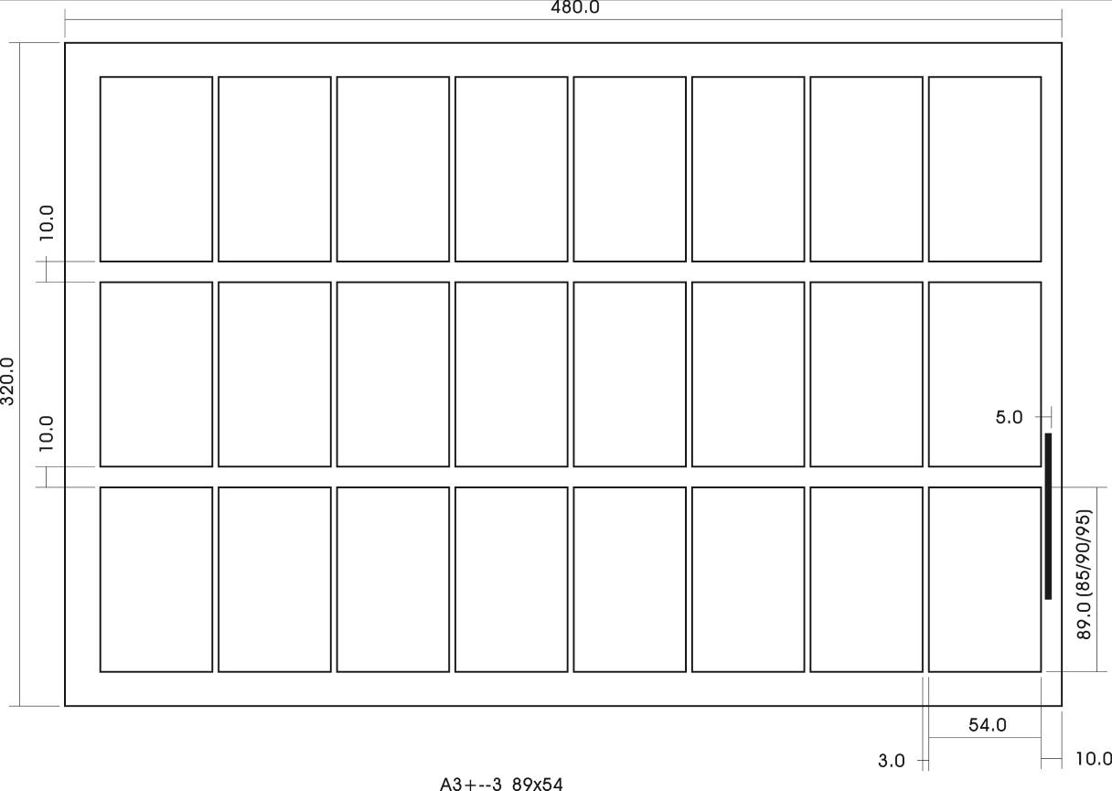

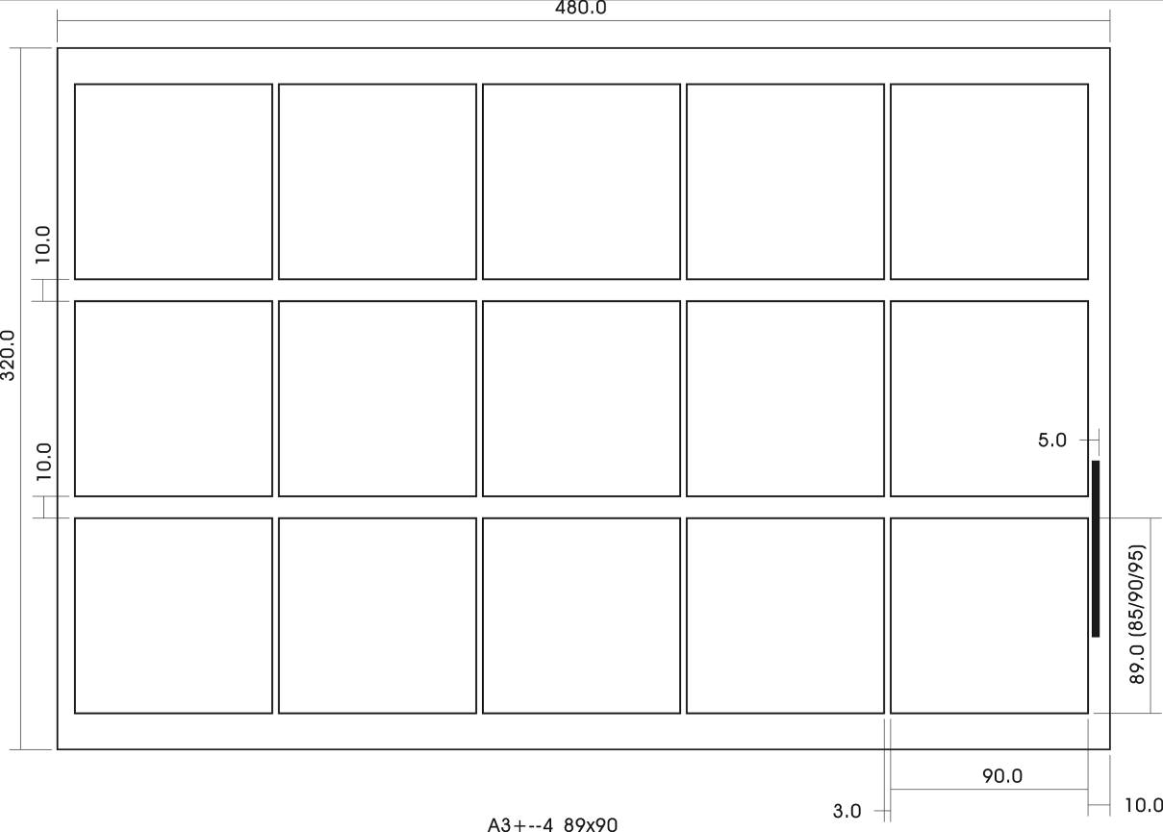
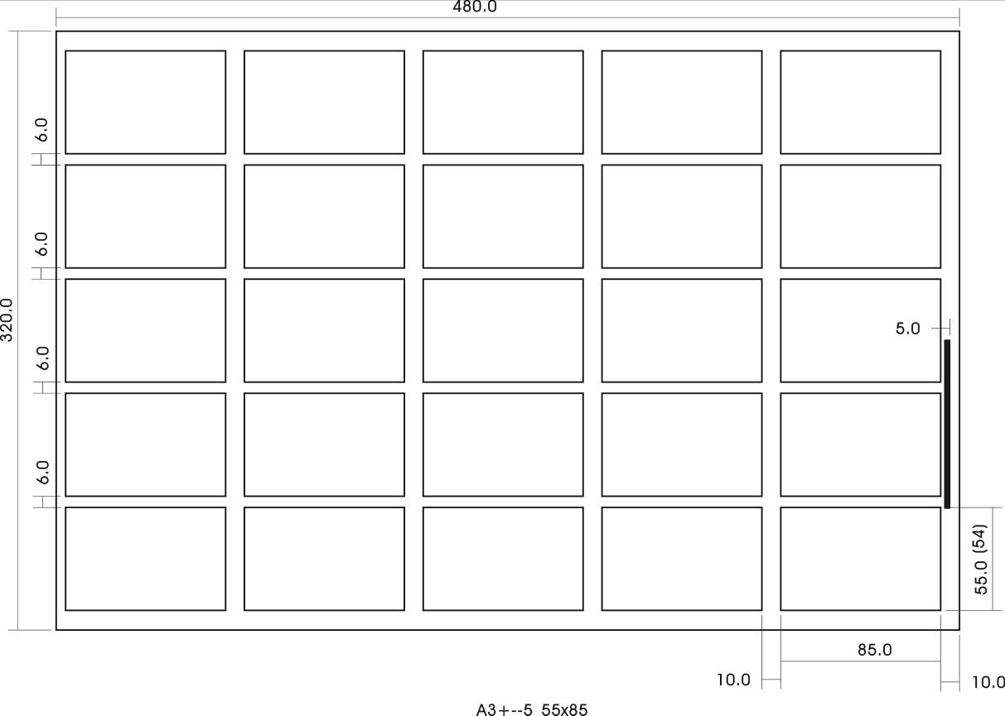

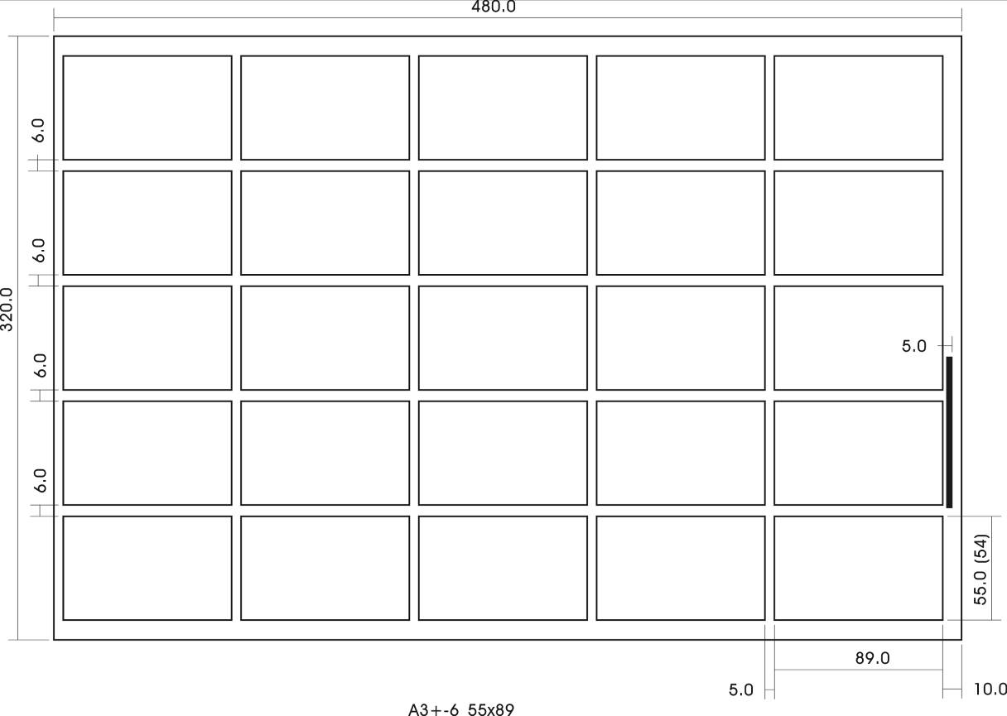
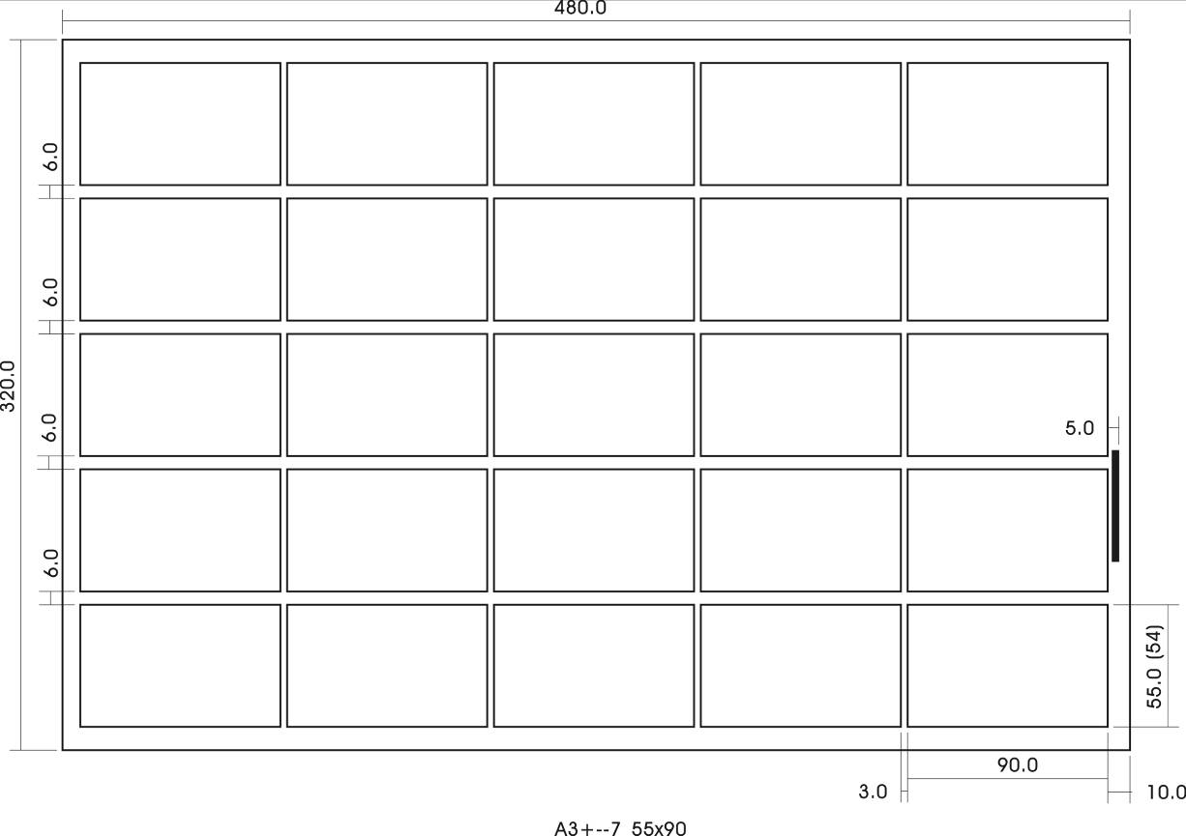

2-4-2: Paper size：A3（297*420mm）
A3--1：89×45mm, use 3-89 rotating cutter group, 3 columns 8 rows total 24 cards;
A3--2：89×50mm, use 3-89 rotating cutter group, 3 columns 7 rows total 21 cards;
A3--3：89×54mm, use 3-89 rotating cutter group, 3 columns 7 rows total 21 cards;
A3--4：89×90mm, use 3-89 rotating cutter group, 3 columns 4 rows total 12 cards;
A3--5：89×95mm, use 3-89 rotating cutter group, 3 columns 4 rows total 12 cards;
A3--6：89×127mm, use 3-89 rotating cutter group, 3 columns 3 rows total 9 cards;
A3--7：spare
A3--8：spare
A3(297*420mm)Typesetting format figure：
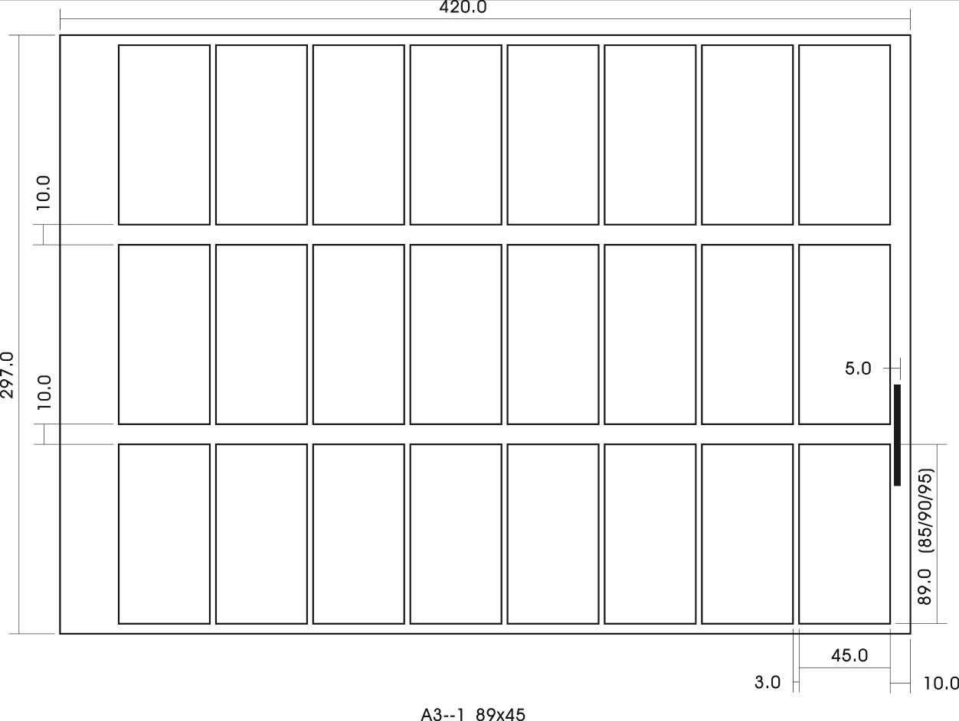
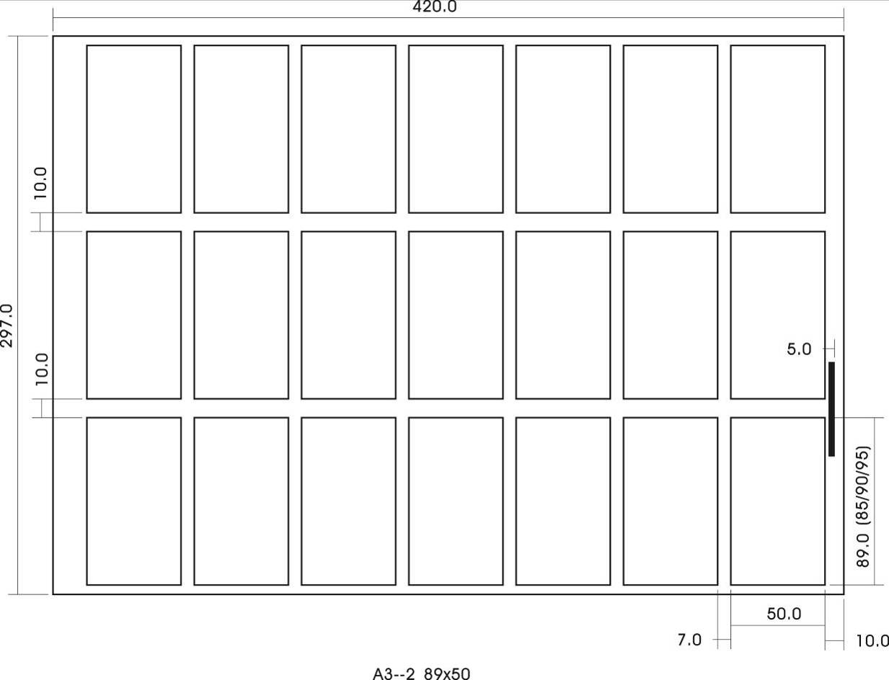
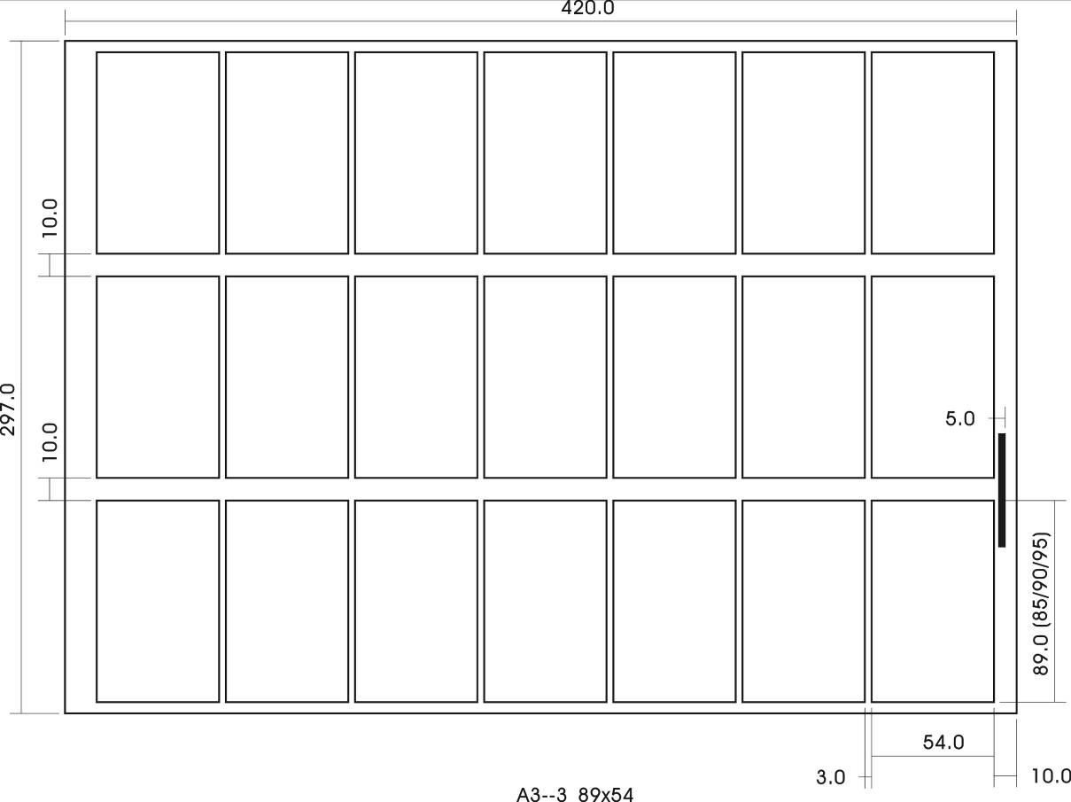

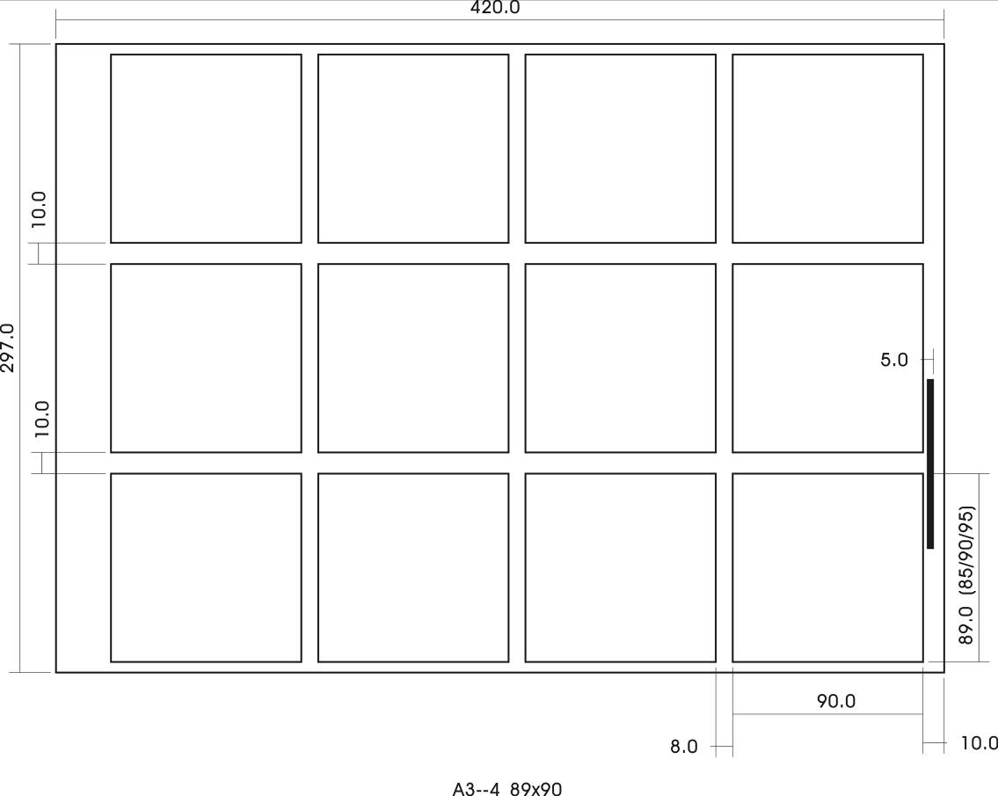
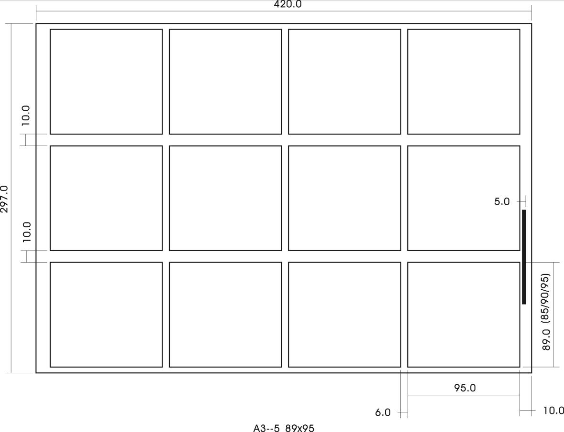

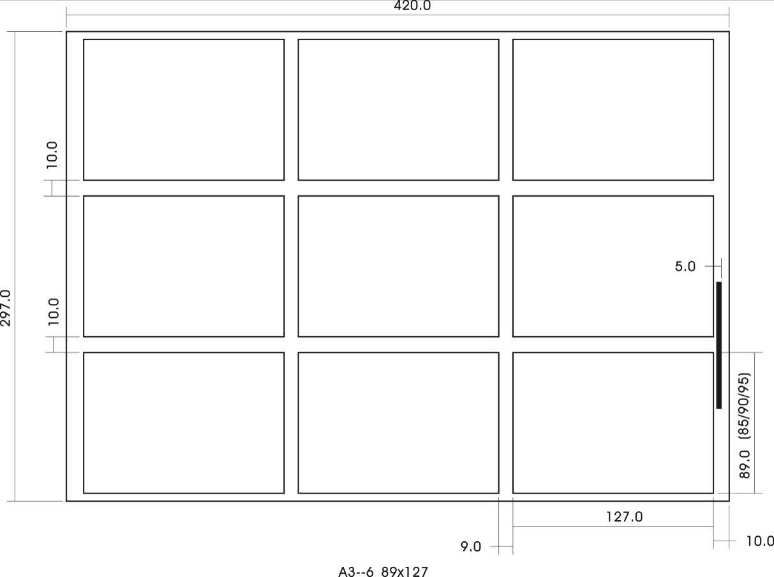

2-4-3: Paper size：A4（210*297mm）
A4--1：89×45mm, use 3-89 rotating cutter group, 2 columns 5 rows total 10 cards;
A4--2：89×50mm, use 3-89 rotating cutter group, 2 columns 5 rows total 10 cards;
A4--3：89×54mm, use 3-89 rotating cutter group, 2 columns 5 rows total 10 cards;
A4--4：89×95mm, use 3-89 rotating cutter group, 2 columns 3 rows total 6 cards;
A4--5：89×127mm, use 3-89 rotating cutter group, 2 columns 2 rows total 4 cards;
A4--6：spare
A4--7：spare
A4--8：spare
A4(210*297mm)Typesetting format figure：
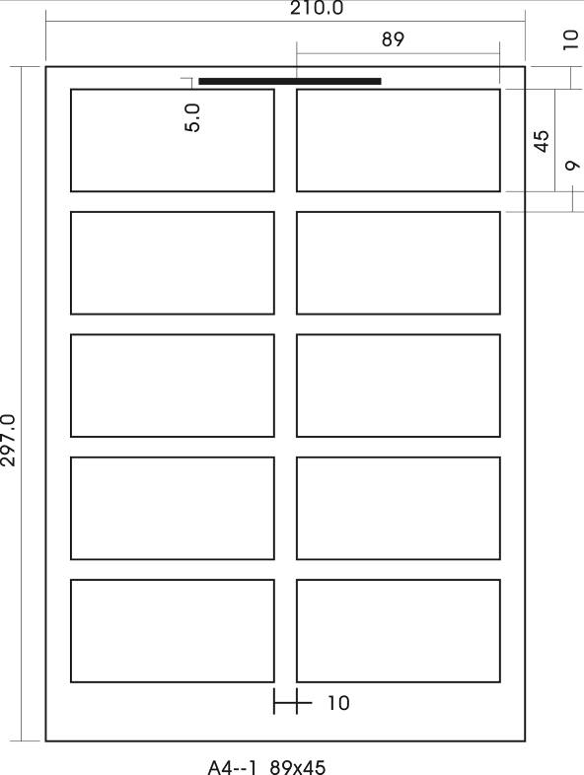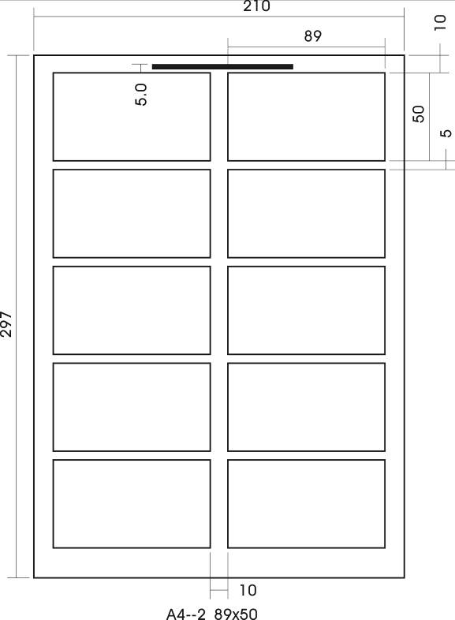
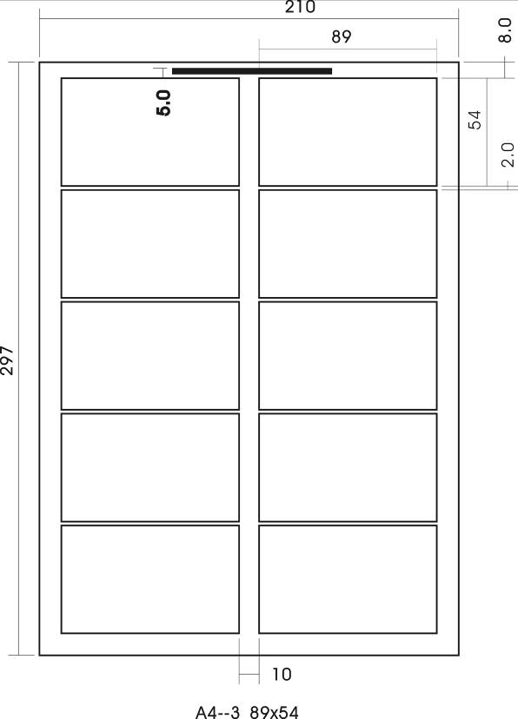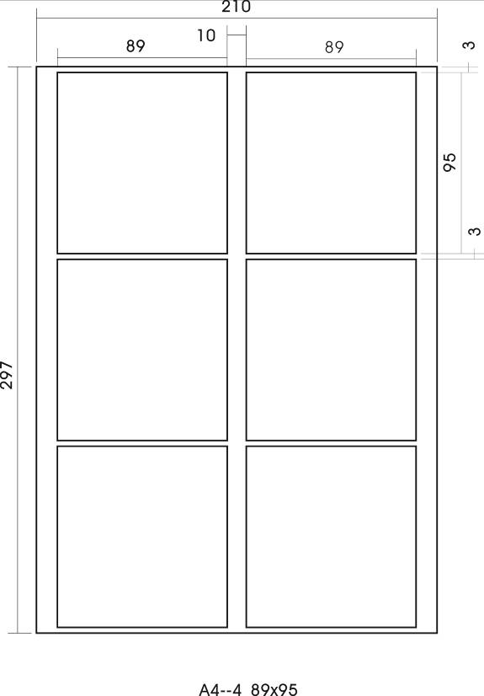
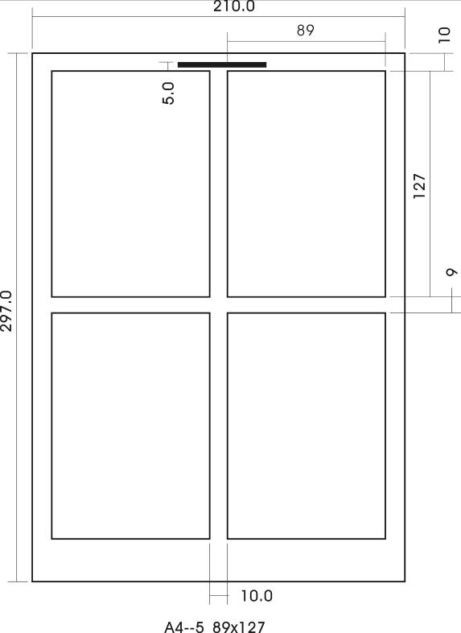

2-4-4: Paper size：custom
custom--1：custom；
custom--2：custom；
custom--3：custom；
custom--4：custom；
custom--5：custom；
custom--6：custom；
custom--7：custom;
custom--8：custom
Custom adjustment with instructions：
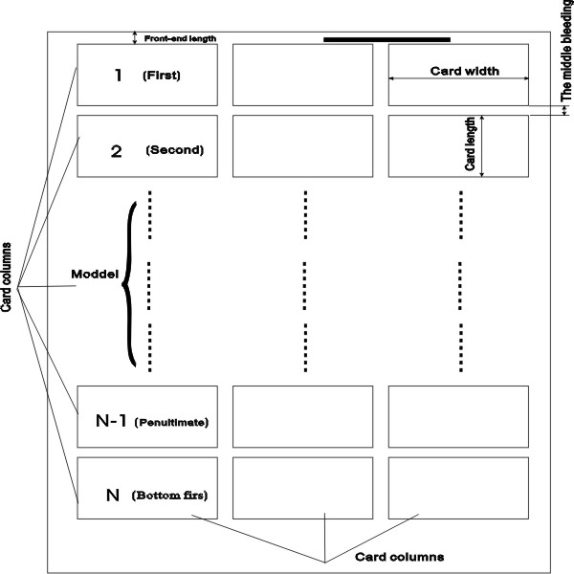
Custom specifications of the card method：
1：In standby interface click "paper choose" piece, adjust to "custom";
2：Click "card specification selection", choose to set the specifications of the serial number;
3：Then adjusted respectively "front adjust length", "card adjust length", "the crumbs of adjustment";
4：Press the "SET" button, into the parameters SET interface, click, which in turn adjustment "card width", "card column number", "card line number"; According to the "back" button to standby interface.
5：Put on paper, press the "start" button to try cutting, measuring card width, such as card length difference, press the "SET" button to "card length compensation";
6：Completing adjustments, batch production. Custom publishing figure
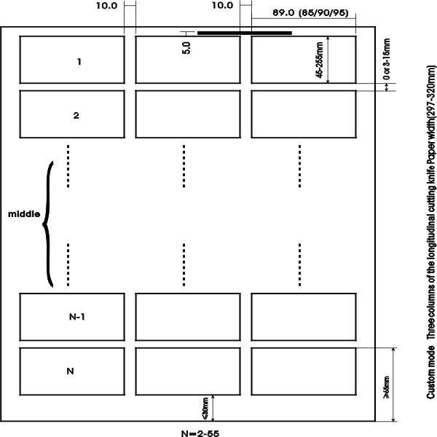
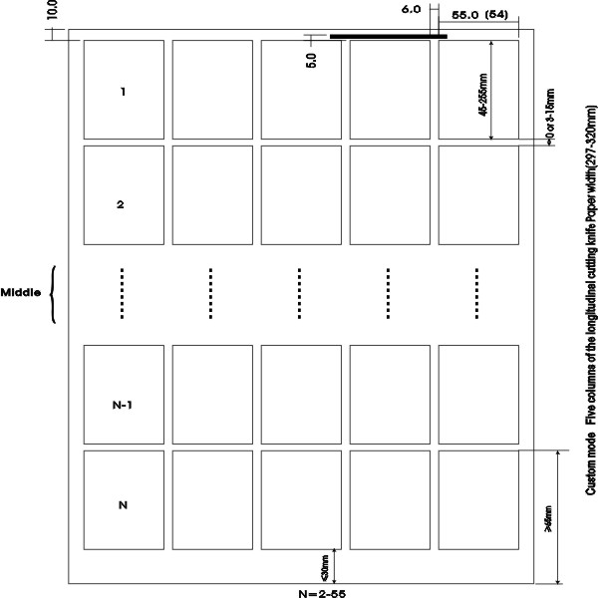

●When set card length is more than 95 mm in less than 127 mm cutting, name card boxes to block should be pulled out cover, see below:

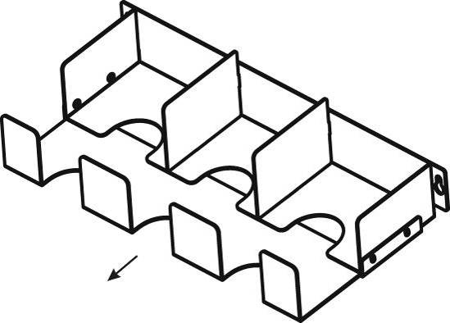
When card length is more than 127 mm, name card boxes will take.

2-5 Parameters set of instructions
●When the actual cutting paper size error, respectively for "front width adjustment, "Card width adjustment, bleeding a regulation" to adjust.
- When need to cutting more A4 papers, need to set the cutting number of sheets

2-6 Operation method and process

⑴ Input power
Turn on the power switch, the machine is initialized, screen to initial interface.
(2) Paper set
  - Alignment ready to cutting paper, printing face up to paper tableUse paper width adjustment: both hands to push and pull paper positioning till paper touched side
  - Don't put too much paper in paper table
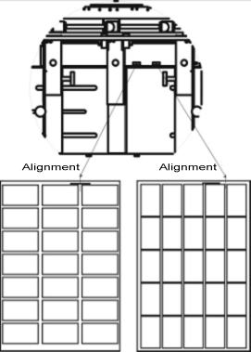
The front of the paper up very roll, can cause to the paper bad, please add after correction.
Please into the same species paper, mixed type into can cause adverse to paper.
(3)cutting position adjustment：
The right and left hands pulled into the paper baffle, to suit Paper size, make printing center/and center Position corresponds with the sign, lock or so lock bar.
(4) Feeding paper
when paper cutting,don't put your finger,hair next to feeding paper wheel,avoid injury.after try cutting,observe whether cut out business card left side,right side in the right position or not.if didn't right,please move "left, right into the paper baffle" adjust until the appropriate.
① Using paper mode setting,please press"start"button,at this time will be set according to the mode of setting size cutting.Feeding paper table will automatically stop after paper use up,and in the standby mode.If you want cutting again,please press"start" key again.
② Cutting over, the whole process is completed, please turn off the power switch.

2-7 The longitudinal cutting knife assembly loading and unloading methods
When loading and unloading,Please click the following process operation
Confirm the power supply has been cut，avoid electric shock.
Don't be touch the knife,avoid hur,please pay more attention when operation.
⑴Loading and unloading methods
① turn off power switch
② Unloaded up cover
Take down name card case
Pull out waste paper box
Pull back cover and then open
Dismantling longitudinal cutting knife with 4 pcs fixed screw
Please gently pull up longitudinal cutting knife,and then take out whole longitudinal cutting knife
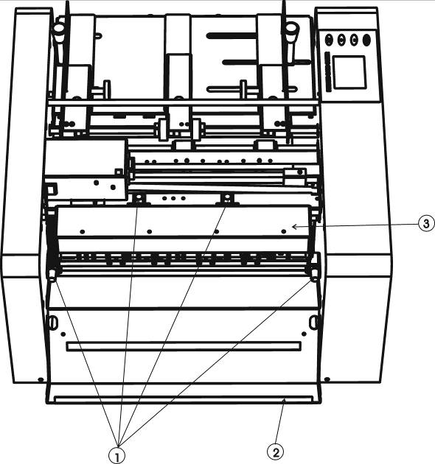
Chart 4
Screw back cover longitudinal cutting knife
⑵Installation method
first put longitudinal cutting knife into suitable position,a little move cutting knife are mounted in,confirm whether gear match or not.
Tight four fixed screw.
Close back cover
Installed on card case
Put back waste paper box
Close up cover
Turn on the power,confirm whether there is a strange voice.

3 Troubleshooting
3.1Cardboard processing
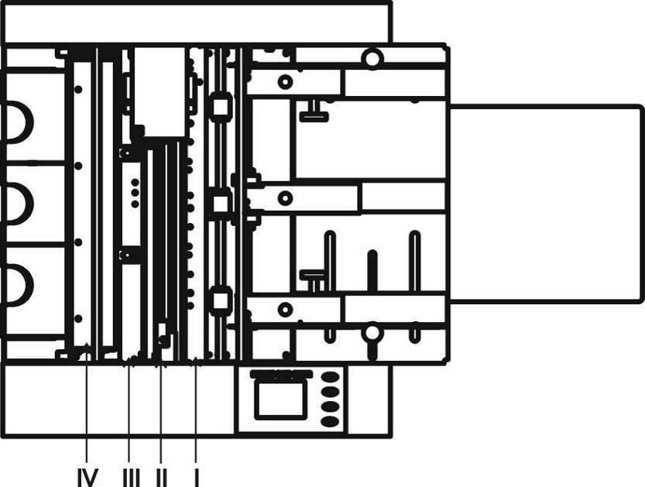
Chart 5
Cardboard parts is divided on the picture above Ⅰ, Ⅱ, Ⅲ, IV four cases：
  - Ⅰ：paperboard in this part , may pressinto manual modes in the initial interface , press the "manual go paper" or "manual refund paper" key, will out of paper or exit;When the paper out after Ⅰ position, gently pull out the paper from feeding paper side.
  - Ⅱ：paperboard in this part，turn offer the power，pull out"waste paper box"，put into hand from installation "confetti box" position,cleared the lock paper , and then "paper box" back.
  - Ⅲ：paperboard in this part，may pressinto manual modes in the initial interface, manual press take away paper key,and then take away.
  - IV：paperboard in this part，need to dismantling longitudinal cutting knife and then close the up cover.
Confirm the power supply has been cut，avoid electric shock
Not suitable size paper will cause problem, please confirm whether appear below matters.
- Paper is too thick (0.30 mm above) or too thin (0.20 mm below)
- paper size long or short than A4.
- Use paper into too much, no more than 25 mm, not more than the red line.
d) Paper too roll
╳ √
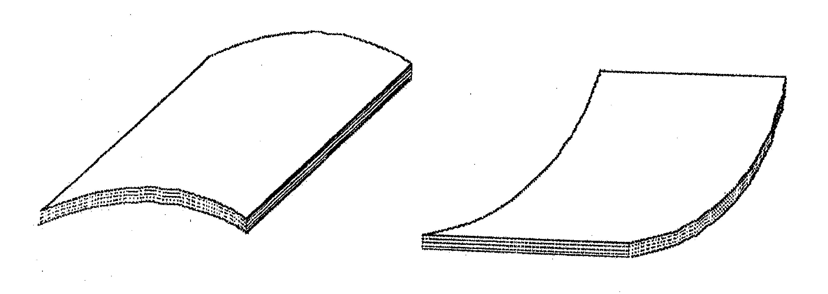
Please do not use the paper shown above, or else bad paper feeding, bad cutting; non-aligned paper etc failures would occur.
【Can not use】Laterally rolled paper.
【Can use】Longitudinally rolled paper, but, the rolled degree is limited within 5mm and the rolled portion must be made flatted.

3-2 Way to settle the warning
The buzzer will sound in case of a mistake with the safety device or paper jamming and the content of it will be shown on the liquid crystal screen and the machine will be changed to stop or stay at the standby state.
LCD screen | Cause | settlement
Safety cover off | The top cover is off | put on the top cover
Pull out paper box | Waste paper box is off or not in the right place | Put into waste paper box or put in the right place
Keyboard fault | Damage in the keyboard | Change the keyboard
Touch screen fault | Screen pressure with strange item | restart it after finishing
Paper into jam | Within the machine have paper scraps residue | Clean up waste paper, especially in photo 5, I referred position.
mark not seen | In the mark detection mode, the mark is not printed or does not confirm the set requirement | Use the frontal end detection mode、  Make the printed mark conform the set requirement.
Knife jam | There is residual paper inside; too thick paper, too rolled paper. | According to the cardboard inside to deal with cardboard
Use mark for narrower paper | Paper too narrow to test | Change paper;instead of  abeled detection

