Ultrasonic Cell Disruptor
User's Manual
KS-750F
KS-1200F
KS-250F
KS-500F
KS-900F
KS-1500F
KS-1800F

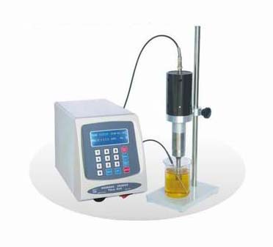
8. Packing List
a. Ultrasonic generator: 1 set
b. Horn: 1 PC
c. Temperature inductor: 1 PC
d. Transducer: 1 set (20kHz)
e. Power cord: 1 PC
f. Connecting wire: 1 PC

NINGBO HAISHU KESHENG ULTRASONIC EQUIPWENT CO.,LTD.
ADD:Ji Chang Road Yong Feng Industrial Zone Ningbo China
Http://www.keshengchina.com

E-mail:ks@keshengchina.com
TEL:86-574-87154938 87152199

verview
Basic Principle
The ultrasonic generator transforms the 110V/60Hz electric supply to 20kHz electric energy and supplies it to the transducer. The barium zirconate piezoelectric vibrator is the heart of the transducer. This vibrator makes elastic deformation at 20kHz frequency along with the alternating voltage. The transducer follows it to make longitudinal mechanical vibration, which causes cavitation effect by the titanium alloy horn immerged in the biologic solution and then activates the excessive vibration of biologic particles in the medium.

1.Main Applications
The ultrasonic cell Vibrator can be used to smash animal and plant cells, bacteria, spores or organizations.
The ultrasonic cell Vibrator is an ideal device to accelerate the chemical, biochemical and physico-chemical reactions as well as to accelerate the liquid degassing.
The ultrasonic cell Vibrator may compound almost centi-

micron sized emulsoid, homogenize “infusible” mixed liquor, aggregate some substances and separate out some another substances.
In brief, the ultrasonic cell Vibrator may realize various functions such as extraction, smash, emulsification, fluid suspension, precipitation acceleration, crystallization and compounding of various biologic specimens under electron microscope etc.

- Structure and Function
Basic Structure
The ultrasonic cell Vibrator is composed of two major parts: ultrasonic generator and transducer.
The generator transforms the 110V/60Hz electric supply to 20kHz electric energy; and the transducer transforms high frequency electric energy to mechanical energy of longitudinal vibration and produces cavitation effect in the liquid phase.
Generator Operating Principle
ＬVPS：(Low Voltage Power Supply) HVPS：

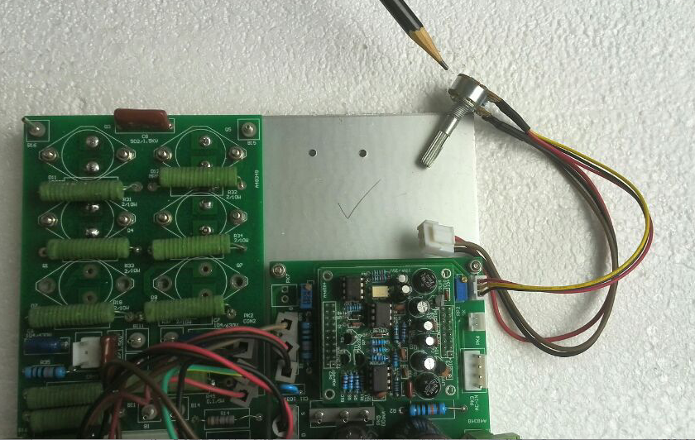
Figure6. It is potentiometer marking W1

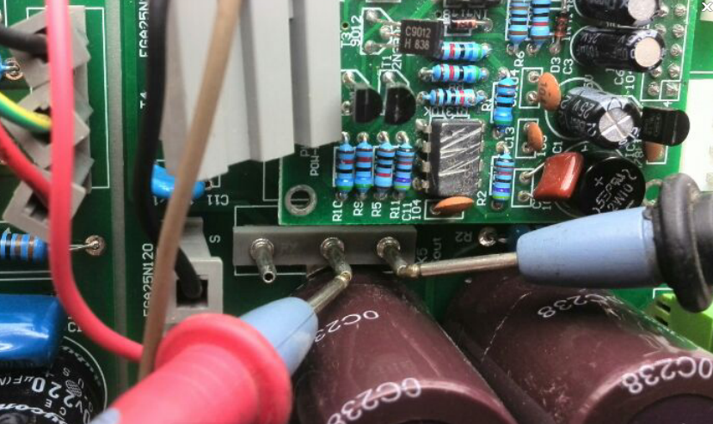Figure5.Pull out the vice plate connector with three holes to test the DC voltage changes within the range of 0-90V.
(3.1.2)
(High Voltage Power Supply)

- Generator Panel
3.1 Explanation of keyboard

LCD screen interface
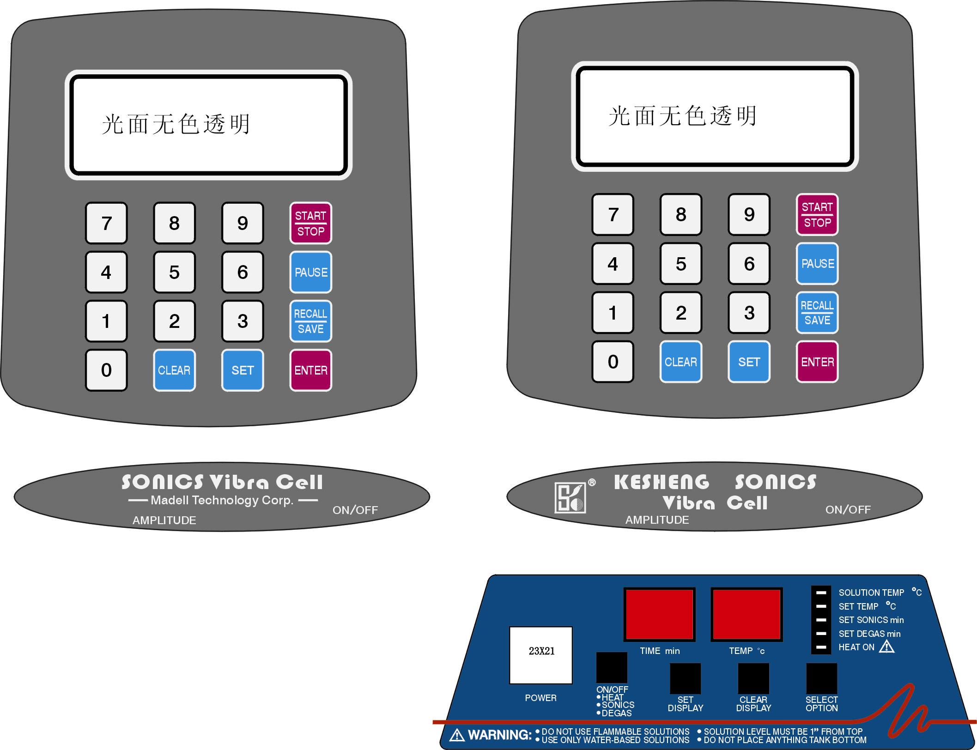

(3.1.4)
(3.1.2)
(3.1.5)

(3.1.6)
(3.1.7)

(3.1.3)
3.1.1 Input of numbers 0~9

3.1.2 CLEAR Key to the clear the last input data.
4
3.1.3 SET Key to set parameters required
3.1.4 START/STOP Key to start or stop the ultrasonic operation
3.1.5 PAUSE Key to pause operations, and when press START again, the operation program will be continued
3.1.6 RECALL/SAVE Key for recall and save, by pressing any number key, you may recall one of the ten saved programs or save a new program to any programmer for further recall.
3.1.7 ENTER Key to confirm a set parameter or program.
3.2 Explanation of LCD screen interface
TIME ： ： TEMP | ºC

PAUSE . ： . AMPL %

ON OFF PAUSE

3.2.1 TIME: Display the work time with max scope of

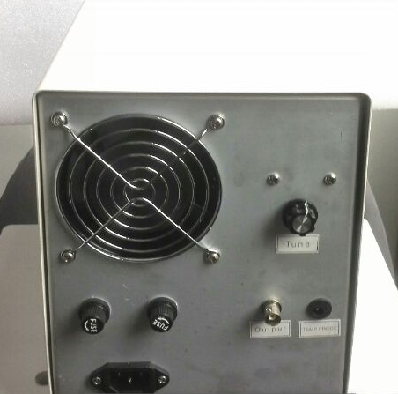
Figure4 .Above the panel there is the tuning knob

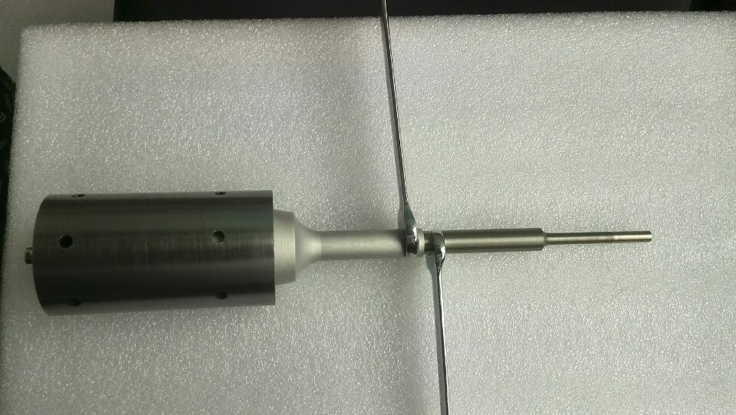
Figure3. Using the special wrench tighten the two end face

time set of 0 hour 0 minute 1 second to 1 hour 59 minutes 59 seconds.
3.2.2 TEMP: Temperature display. On the left of the sign “│” is the set temperature and on the right is the measured temperature.
3.2.3 PULSE: Display the pulse width under the pulse (intermittent) operation mode. On the left of the sign “:” is the width at start and on the right is the width at stop.
3.2.4 AMPL: Display the output amplitude percentage.
3.3 Explanation of main power switch and output amplitude adjustment
3.3.1 The main power switch is installed at the right lower part of the panel bottom. When the power is on, the right light of the switch turns on and when the power is off, the right light turns off.
3.3.2 The amplitude adjustment button is installed at the left lower part of the panel bottom. In the clockwise direction, the amplitude increases and in the anticlockwise direction, the amplitude reduced.
4. Directions for Use

4.1 Preparation
Connect the power cord and the contact of transducer in a correct way. Confirm that the transducer has a load before operation. Never operation without load.
4.1.1 Connect the generator and transducer with wire.
4.1.2 Install the transducer on the test bed. Immerge the titanium alloy horn in the liquid with depth dependent on the material capacity and diameter of horn end. Generally, the more the horn approaches the container bottom, the better the smashing effect will be.
4.1.3 Insert the power cord into 110V/60Hz power socket with ground connection device.
4.2 Start the machine
Turn on the main power switch. When a sound of “Di” is given, the screen displays a working interface as shown in the above figure. If there’s no action when the machine is started, turn off the main power switch immediately and pull it out of the power jacket. Check for the correct connection of power cord and correction installation of fuse. Start the machine again when everything is

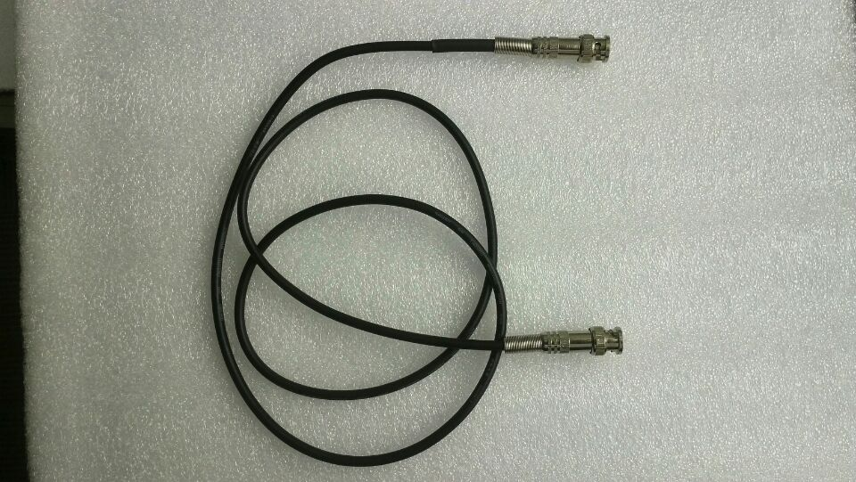
Figure 2.It is the cable of linking

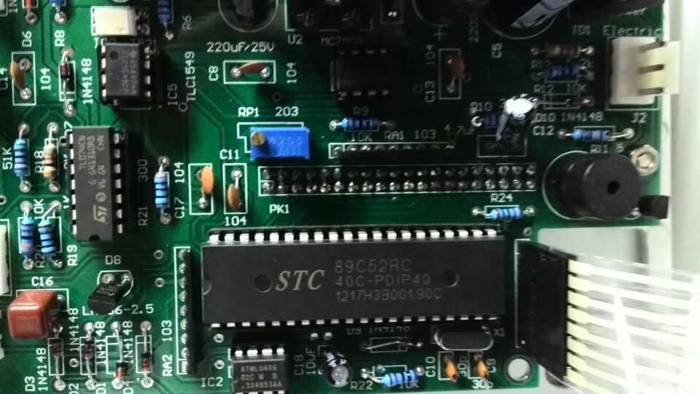

Figure1. In the middle of the control panel there is the potentiometer

confirmed correct.
4.3 Set working parameters
After the normal starting of the machine, press the key SET. When a sound of “Di” is given, the machine enters the program setting status, the number nearest the TIME on the LCD display is inversed.
4.3.1 Set working time
When the number nearest the TIME is inversed, press a number key to input the time required. For each number input, the inversed mark will auto shift to the next number and the place of first number has displayed the number just input. For an error input, you may press the key CLEAR to remove the data input in the previous step. At this point, the inversed sign goes back to the place of the previous number waiting for inputting a number again. Repeat the above operations until all working time is input.
4.3.2 Set maximum working temperature
After entering the interface for setting, if continuously press the key SET or hold down the key SET, the inversed

sign will shift to all parameters in cycle in clockwise direction. Control the key SET, shift the inversed sign to the first number after TEMP. Then press a number key to input the desired maximum working temperature. When the measured temperature reached the maximum temperature working temperature, the ultrasonic operation will be stopped.
4.3.3 Set pulse width under the pulse (intermittent) operation mode
After entering the interface for setting, if continuously press the key SET or hold down the key SET, the inversed sign will shift to all parameters in cycle in clockwise direction. Control the key SET, shift the inversed sign to the first number after PULSE. Then press a number key to input the start time and stop time. On the LCD display screen, the first group data on the right of PAUSE indicates the start time, the data on the right of “:” indicates the stop time. During pulse operation, neither group of data is read zero. For operation in continuous status, only set the stop time on the right of “:” at “0.0”.

note

After restart the changed fuse still is damaged. That needs to check the circuit fault:
1. To detect the power triodes, BUX 98 A marking Q1, Q3. Q4. Q5. Q6. Q7. Pull out the connector with single holt, B15 and B16, there are on the both side above the main plate .Then to test these triode .Generally one triode has damaged then to be changed.
2, To detect the change of amplitude .Pull out the connector with three holes, marking PK5 DC OUT (figure 5), of it is in the middle of the vice- plate. Use the voltmeter-pole and test the dc-voltage connecting to the tow points of the connector, middle and right. To observe whether the dc-voltage is changing. The method is to rotate the knob, marking AMPLITUDE, that is at lower left ,observing the voltmeter changes within the range of 0-90V .If the potentiometer , W1 (figure 6), has damaged so that no changing. .To changes it.
3, To test the field effect tube, IRFP460, if it is damaged will be changed..

s
6
Is abnormal ultrasonic | deviation | knob TURN of the rear panel (figure 4), according to clockwise or counterclockwise fine-tuning, capture the resonant point.
Display shows overload, and ultrasound | a、 start moment output power is too large  b、 resonance point deviation | a、before the start of the amplitude knob counterclockwise AMPL, lower amplitude  b、 rotating tuning knob on the rear panel, adjustable quasi resonant point
After start-up ultrasonic instantly stopped | Temperature value is higher than the actual temperature value | Set higher temperature

The maximum pulse width in pulse operation is “9.9:9.9” seconds.
4.3.4 Set the amplitude output percentage
Turn the amplitude output control knob AMPL. When turn in clockwise direction, the amplitude increases and in anticlockwise direction, the amplitude is reduced. Adjust until the number beside the AMPL on the display screen reaches the desired size.
Note: 1. The amplitude output percentage is the only parameter that cannot be saved. It shall be set by manual turn of the knob before operation.
2. Before the machine is started, the amplitude output percentage is generally set below 40%to avoid failure caused by oversize instantaneous current.
4.4 Parameter save and recall
4.4.1 Save
On the parameter setting interface, when all parameters are input, if such program is to be saved, click the key RECALL/SAVE, and SAVE TO ID will be displayed in the last line of the screen. Press any number

key and then press ENTER. Except the amplitude, all programs on LCD screen are saved to the memory related to the number key just pressed. The machine may save 10 program sets with corresponding numbers of 0~9.
Note: If you do not want to save the current program and the program on LCD screen is only for temporary use, then after inputting all parameters (or partial parameters), directly press the key ENTER, and the parameters on the display screen (except the amplitude) will be saved in the temporary memory as the initial program when the machine is started next time.
4.4.2 Recall
When the machine is in leisure state (starting state), press the key RECALL/SAVE, and RECALL FROM ID will be displayed in the last line of the screen. Press any number key and then press ENTER. At this point, the content from a memory corresponding to the number key pressed will be recalled on the display screen.
4.5 Start/Stop and Pause
4.5.1 Start/Stop

The common failures and troubleshooting methods
The fault phenomenon | Cause analysis | Elimination method
Open the power switch display screen is not bright. | a、 the fuse damage  b、 the damage of the power switch  c、Power supply device is fault | a、 replacing the fuse  b、 replace the power switch  c、check whether the power cord in contact with good, whether the power outlet have power source
Open the power switch display screen shows abnormal, dim or Very bright | a、the local power supply voltage is not stable  b、There are differences between the power supply voltage all over the word. | Adjust potentiometer RP1-203, in the middle of the screen on the back of the control circuit board position (figure 1) make the brightness moderate
 | a、 and cable (figure 2) poor contact  b、amplitude transformer joint (figure 3) not tighten  c、 ultrasonic resonance point | a、and reinstall the cables  b、 the amplitude transformer links the two end fixed flat, and tighten  c、adjust the tuning

tarting which may damage the power tube.
6.8 When smashing biomaterials or being used for other purposes, first test and adjust with clear water.
6.9 When the ultrasonic strength is insufficient, the horn contact may become loose including loose “tip” may also cause insufficient ultrasonic strength or abnormal sound, you should check and turn tight.

After setting the programs, the machine is ready for work as required. Check the output amplitude again, press the key START/STOP and the machine starts working. At this point, a sign of ON or OFF will display under the number corresponding to the PAUSE on the screen, which indicates the ON/OFF status during pulse operation. The working time TIME begins to count down the time. At this point, press the key START/STOP again, the working status will be stopped and the screen display resumes its initial status.
4.5.2 Pause
In working status, press the key PAUSE, the sign PAUSE will appear in the last line of the screen to indicate that it is presently in pause status. Press the PAUSE again or press the key START/STOP, then it exits the pause status and returns to working status. The sign PAUSE will disappear at the same time.
4.6 Pulse and continuous operation

5 Technical parameters

Parameter/model | KS-250F | KS-500F | KS-750F | KS-900F | KS-1200F | KS-1500F | KS-1800F
Max power (W) | 250 | 500 | 750 | 900 | 1200 | 1500 | 1800
Frequency (kHz) | 20 | 20 | 20 | 20 | 20 | 20 | 20
Permissible end  Diameter titanium alloy horn | 1/8”  1/4” | 1/8”  q1/4”  q3/8” | 1/8”  1/4”  1/2” | 1/4”  1/2”  9/16 | 1/4”  1/2”  9/16”  3/4” | 1/4”  1/2”  9/16”  3/4”  1” | 1/2”  9/16”  3/4”  1”

5.1 Power requirement of generator: 110V, 60Hz. Frequency output: 20kHz.
5.2 End diameter titanium alloy horn (inch):

6. Points for Attention
6.1 The pulse acting mode is generally adopted, which is good for even smash and radiation as well as for keeping the activity of the biomaterials.

6.2 110V/60Hz power socket shall be provided with ground connection device.
6.3 The titanium alloy horn shall be immerged in the
6

liquid for a certain depth. Insufficient depth will cause the air above the liquid surface mixed into the liquid and produce empty vibration, which influences ultrasonic effect. Generally, the horn may approach the container bottom.

6.4 When using the titanium alloy horn, the amplitude percentage shall not exceed ％ . Otherwise the oversize amplitude of vibration may damage the horn.
6.5 High viscosity test material shall be diluted to avoid output failure of ultrasonic energy, which may damage the equipment.
6.6 Tight connection between the horn and transducer shall be maintained. When it becomes loose, failure will occur. The plane joint between the horn and transducer shall be maintained flat and clean. Stains, if there’s any, can be wiped clean with alcohol cotton ball and then cleaned with paper or dry cloth.
6.7 Before starting, set the amplitude percentage below “40%” to avoid heavy current produced at the moment of

6

