Modular Nitrogen Generator - User Manual -

CATALOG

1.Technical Parameters
1.1 Design Parameters
1.2 Capability Parameters
1.3 Utilities

2. Safety
2.1 Application
2.2 Preventing Accident
2.3 Danger Source

3. Function and System Structure
3.1 Using CMS to separate air
3.2 Pressure Swing Adsorption
3.3 Process flow
3.4 Air compressor and purification system
3.5 Air Separation
3.6 Nitrogen Storage and Supply

4. Installation
4.1 Installation Requirement
4.2 Normal Installation way

5. Operation

5.1 Control System
5.2 Control process
5.3 Oxygen Detector
5.4 Start-up
5.5 Shut-down

6. Maintenance and Troubleshooting
6.1 Daily Check and Maintenance
6.2 Possible Malfunctions and Troubleshooting
6.3 List of spare parts

7. Appendix
7.1 Flow Diagram
7.2 Electrical Diagram

TECHNICAL PARAMETERS
1. Technical Parameters
1.1 Design Parameters
Requirement of Compressed Air :

Compressed Air Flow Compressed Air Pressure Compressed Air Dew Point
1.2 Capability Parameters
The Request of Nitrogen :
N2 Flow

Purity
O2 content

N2 Dew Point
N2 Pressure

1.3 Utilities

≥180L/min
≥0.7MPa
2C-10C

63.6CFH（30L/min)
≥99.99% （anaerobic)
≤0.01%
≤-40℃（ atmospheric pressure)

0.6MPa

Power Voltage
Power

400V/50Hz /3P three-phase-five-wire system

3kW

SAFETY
2. Safety
It is necessary to thoroughly read this manual first before using the equipment, and operate and maintain it strictly according to instructions so as to avoid causing of equipment breakdown. GSE Tech (Suzhou) Co., Ltd. will be responsible for the guarantee of the equipment. However, GSE Tech(Suzhou)Co.,Ltd. will not take the responsibilities for damages caused by user’s improper operation or faults.

2.1 Application

PSA nitrogen generator system is designed with flow and purity described in chapter 1.2. However, without the permission of GSE Tech (Suzhou) Co., Ltd. may not be changed as follows :
·Setup changing goes beyond the limitation stated in part
1.2 ·Changing Hardware setup in system
If the above situations happen, the quality-guarantee is invalid.

2.2 Preventing Accident
All standards of preventing accidents are prescribed by Legal department of country. Operator should be complying rigorously.

3.3 Danger Source
Healthy Harm !

SAFETY

Compressor, dryer and PSA System may run automatically under the mode of automatic manipulation. Therefore, before maintenance, the whole system and all parts of system must be shut down.

Fire!
Waste gas generated by the system contains nearly 35% highly concentrated oxygen, it is easy to cause fire. Thus this machine should be placed outdoors or the place with good ventilation, and smoking is strongly prohibited.

Asphyxia!
Nitrogen which generated by the machine will not provide enough oxygen for breathing. Thus product gas should not be used to breath.

Healthy Danger !
All parts of the equipment and pipelines are in high pressure and gas will expand immediately when disassembling and cause directly or indirectly damage to humans. So, high pressure gas in all vessels and pipelines should be released before maintenance.

FUNCTION AND SYSTEM STRUCTURE

3. Function and System Structure
Nitrogen will be generated by separating Oxygen from air through Pressure Swing Adsorption technology.

3.1 Using CMS to separate air
CMS (Activated Carbon Molecular Sieve) is a specially treated material. It is used to separate air.

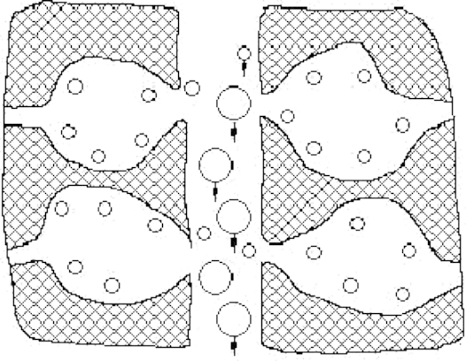

drawing 3.1 Separating Air （CMS)

The diameter of the holes in CMS is between the diameter of nitrogen molecule and oxygen molecule. It is because of oxygen molecule’s bulk is smaller and lighter than
nitrogen molecule that oxygen is Adsorbed prior to nitrogen. See drawing 3.1.

3.2 Pressure Swing Adsorption ）PSA)
More and more molecules will be adsorbed in the surface of CMS, see drawing 3.2.

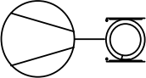
消 声 器

PT
101

TT
102

TT
101

V103
PI
103
P
P
PI
104
PV106 PV107
F102
过滤器 Filter
P
V102
PV108
H101 Pre-Cooler
H102
冷干机 Refrigeration Dryer
C101

Air Compressor
V104
N2 Tank
AV02
Column B
V103
AV01
Column A
空压机及后处理
Air Compressor and post-processing equipment
P
PI
102
PV101
S
S
F101

Filter

FUNCTION AND SYSTEM STRUCTURE

Compressed air goes into one adsorption tank and flows from the bottom to the top of the tank.
空气压力越高,CMS 表面所吸附的气体分子越多,如图 3-2 所示,压缩气体进
入一吸附塔,从下到上流经塔体。

Control System

V101
P
P

图例说明
PV103
PV102
P
P
PV105
PV104
S

98%output

Filter

Global Valve
V113
V112
V114
S

SL101/102
PI 104
Ball Valve

Solenoid Valve

Instrument
Safety Valve
V111
S
99.9%output

Flow Meter
FIC
10 1
Flow Meter

99.99%output
V107
V109
Check Valve
F105
Filter
P

Pressure Regulator
Pneumatic Valve
V108 V110
Modular nitrogen generator
Vent

drawing 3.2 Pressure Swing Adsorption （PSA)
Oxygen Analyzer V111

The adsorption tower is filled with molecular sieves and when the gas goes through from the bottom to the top, the oxygen molecule and nitrogen are both adsorbed on the surface of the molecular sieves. However, the quality of oxygen is more than nitrogen molecules. In that way the nitrogen gas goes from the outlet from the tower while most oxygen is adsorbed.

The adsorption time depends on the airflow rate. The relation is explained as following:

The higher air flow rate and shorter adsorption time will result in higher nitrogen concentration.

FUNCTION AND SYSTEM STRUCTURE

★ The lower air flow rate and longer adsorption time will result in lower nitrogen concentration.
· 流速低→氧吸附时间长→产品气中剩余氧含量低→氮气纯度高
When adsorption of adsorbent reaches to saturation, it needs regeneration. The regeneration is caused by decompression. Due to the features of gas adsorption, it provides
de-adsorption under low pressure. Therefore the adsorption and regeneration of adsorbent can be repeated according to the principle stated above, assuring the continuous production. When one absorber is regenerating, the other absorber is in working.

3.3 Process flow 工艺流程
PSA Nitrogen Generator Process can be divided into three units:
制氮分为三个部分:
· Air compressor and purification system
压缩空气及净化
· Oxygen and nitrogen separation unit
空气分离
· Nitrogen storage and supply
氮气储存及供气
3.4Air compressor and purification system

The compressed air (about 0.8 MPa ) first enter into the 9 grade filter to remove most water, other condensed liquid which is larger than 3 um (remnant oil less than 5ppm w/w). Then the refrigeration dryer will take most oil, water and dust from compressed air. The latter 7 grade filter will further remove the liquid water, oil and solid granule which is larger than 1 um (Remnant oil less than 1ppm w/w). Next step, the 3 grade filter will remove solid granule larger than 0.01ȝm(Remnant oil less than
0.01ppm w/w). Finally, the 1 grade filter will absorb oil vapor and hydrocarbon vapor to 0.003ppm

FUNCTION AND SYSTEM STRUCTURE

w/w, which meets the demand of PSA system.
需空气质量。
Under rated running conditions, the 1 grade filter can normally work
continuously for more than 4000 hours.
在额定运行条件下,1 级活性碳吸附器设计寿命为 4000 小时。
After activate carbon tank, the compressed air will reach the required specifications:
经活性碳吸附器后,空气进入吸附塔 A、B,其中杂质含量如下:
· Oil remaining amount in the air: ≤0.003mg/m3 (21℃)
· Solid particulates dimension: ≤0.01 um
· Moisture remaining amount in the air: ≤5.57g/m3
·

The condensed water from compressed air will discharged to specific place through pipeline.
压缩空气生成的冷凝液通过冷凝排放管排放到指定地点。
3.5 Air Separation
After air purification system, compressed air enters into Adsorber A or B for adsorption through pneumatic valve PV102 or PV103.

Adsorption column A or B with carbon molecular sieve, is the main part of the nitrogen generator, the oxygen and nitrogen separation is done here.Carbon molecular sieve compressing adopt automatic pressing device .

The whole process flow is controlled by 8 valves from PV101 to PV108. See the Table 3-1.

塔开始吸附,
艺。

FUNCTION AND SYSTEM STRUCTURE

3-1 Periodic Procedures 运行步骤

Status  吸附塔状态 |  |  | Valve Opening |  | Description
Adsorption in A |  | and | PV102 、PV106、  PV105 |  | Adsorption and separation in A and regeneration in B
regeneration in B
Pressure balance in A and  B |  |  | PV101、 | PV108 | Pressure balance of | these two | towers,
 |  |  |  |  | adsorption and preparation for regeneration
Regeneration in A |  | and | PV103 、PV107 、PV104 |  | Regeneration in A and adsorption and separation in B
adsorption in B
A 塔再生, | B 塔吸附
Pressure balance in A and  B |  |  | PV101、 | PV108 | Pressure balance of these two towers, adsorption and preparation for regeneration

3.6 Nitrogen Storage and Supply

FUNCTION AND SYSTEM STRUCTURE

· Nitrogen storage tank :
Material: carbon steel, easy to clean, pipe material selection of stainless steel, the welding is reliable.
·材质选用碳钢,易于清洁,管道材质选用不锈钢,焊接处可靠。
In accordance with, "container safety supervision regulation of pressure vessel" implementation design, a nitrogen tank and pipeline design pressure is greater than or equal to 1.0Mpa.

Buffer, by PSA process caused by pressure fluctuation that adsorption tower A and B in adsorption at the start of the pressure minimum.
·在吸附开始时的压力最小值
Ensuring the adsorption tower, A and B in adsorption at the start of the minimum pressure value, its role is buffered by PSA process caused by pressure fluctuation.
·

The nitrogen flow is adjusted by manual valve V107 through flow meter F101 and then
enters application point. The flow meter F101 shows the real flow that output.

The device configuration on gas flow meter, product function, unit Nm3/h.In general, the flowmeter calibration under normal conditions, specific conversion as follows:

The sampling pipe was installed in nitrogen outlet to detect the nitrogen purity.

INSTALLATION

4.1 Installation Requirement
1)Clean and dry compressed air
2) 220V/50Hz power source
4.2 Normal installation way
The nitrogen generator should be laid on the tidy and horizontal ground. A place with good ventilation is needed. If it is placed in a sealed area, air with over-oxygen and unqualified nitrogen should be emitted outdoors with pipes.

OPERATION

5.Operation
5.1 Control system

SIEMENS CPUSR30 Type PLC is applied to this control system. 8 pneumatic valves will be controlled by the PLC. Oxygen analyzer detects oxygen concentration and when the
concentration exceeds the setting value, the PLC will alarm to call attention to the manipulators to open the unqualified gas outlet valve and close the nitrogen outlet valve to prevent unqualified nitrogen going to the next system.发出信号提醒打开不合格气 出口阀,关闭氮气出口阀,让气体直接放空,防止不合格气进入下工段。
5.2 Process Control
·Main Process Control :
The system is composed of PLC and pneumatic valves PV101- PV108. Pneumatic valves open and close as programmed to accomplish adsorption, regeneration and pressure balance of the PSA system.
闭,自动完成 PSA 过程的吸附,均压和解吸。
·Instruction to Control Panel :
Control cabinet operation panel on the touch screen display, pressure gauge,. See drawing 5-1.

5-1。

OPERATION

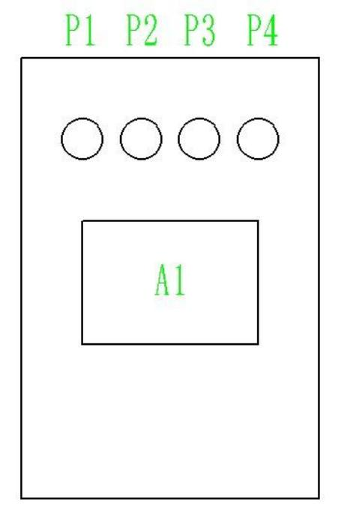

Drawing 5-1 Control panel display

1. HMI （A1)
Display all the valve working condition as well as the adsorption time.
显示各个阀门的工作状态以及吸附时间等。
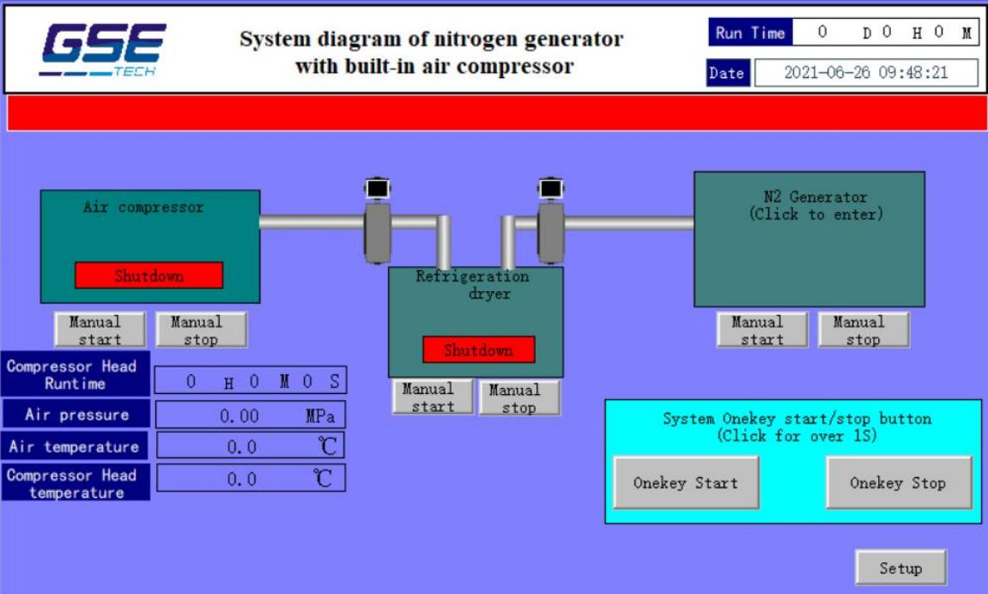

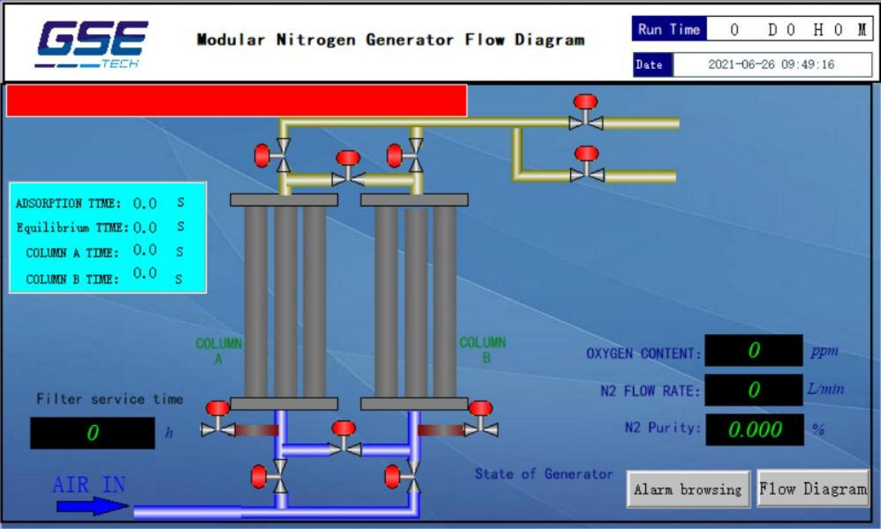
点击"一键启动”--制氮机开始顺序启动(先启动冷干机,再启动空压机,再启动制氮机; Press“Onekey Start”--N2 Generator start to work.
Press“Onekey Stop”--N2 Generator stop work.
Press“Setup”--Parameter setting.
Oxygen Content: ppm of oxygen content in N2
N2 Flow Rate: Flow rate of N2 out
State of Generator: Green,PLC work,N2 Generator work;Red ,PLC stop work,N2 Generator stop work;

2.Pressure gauge(P1、P2、P3、P4) P1-P4:
P1-P4 show the Pressure of Air Inlet;adsorber tower A;adsorber tower B and nitrogen tank力表分别显示空气压力,A 塔压力、B 塔压力和氮气罐压力。

5.3 Oxygen analyzer
The remnant oxygen content is detected by the oxygen analyzer continuously The sampling pipe is composed by:
·The relief valve to adjust the sampling gas pressure ·The regulating valve to adjust the sampling gas flow

的氮气中剩余氧含量是由氧分仪连续监控的。

Detect the remnant oxygen content :
1. Adjust the sampling pressure to 1.0bar
2. Adjust the sampling flow till the gas can be felt
3. The oxygen content can be obtained when the reading is stable
To keep the oxygen analyzer in precision, Calibration is needed regularly. At the meantime, the sampling flow and pressure should be checked in a fixed time. See the instruction of the oxygen analyzer.
Caution:There are three minutes for oxygen analyzer preheat from the Power ON. During this period, it is forbidden to start the nitrogen generator,otherwise the valve will act abnormally.

5.4 Start-Up:

1) Start the air compressor and make it meet the requirements of this machine (required conditions). Open the inlet valve of nitrogen equipment and adjust the pneumatic valves gas source valve to 0.5-0.6Mpa.

2) Turn on the switch of nitrogen machine and oxygen analyzer on the control panel. Then set the allowed max value on the oxygen analyzer. Whether they two adsorption towers work normally are judged by the pressure switch between the two towers. During normal working, the pressure of the adsorption tower should be almost the same as the compressed air (perhaps lea than 0.05MPa ) while the regeneration pressure is 0. At the balance stage, the two towers has the same pressure (about a half of the adsorption pressure).

3) Turn on the oxygen analyzer and open the sampling valve to regulate the pressure to 1.0 bar. And then adjust the sampling flow till the gas can be felt by hands. Notice the sampling flow should not too large.

- The purity and flow rate of nitrogen can be adjusted by adjusting the opening of nitrogen outlet valve v107.

OPERATION

5.5 Shut Down:
(A) . Press “Onekey stop”
按停止键;
(B) close nitrogen product outlet valve and sampling valve.
(B). Inlet valve of compressed air shall be closed.
(C). Switch of nitrogen machine shall be turned off. 。

POSSIBLE MALFUNCTIONS AND TROUBLESHOOTING
6.1 Daily Maintenance and inspection

Inspection | Inspection method | Rated value | Period
Filter
Discharge | Check whether there is effluent  from the discharge outlet |  | Daily
Clean of the
build-in | Take the valve apart and clean in |  | Every
discharge valve | neutral solution |  | week
The compressed air buffer tank
Pressure gauge | Check whether the pressure is in  normal range |  | Daily
Discharge valve | Check whether there is effluent  from the discharge outlet |  | Every two hours
PSA System PSA

Oxygen  analyzer | Check the sampling flow and pressure, if needed, adjust them. | The gas can be felt  by hands | Daily
 |  | 0.1Mpa
Flow meter | Check the flow meter and adjust it if | ≤30L/min | Daily
 | needed. The flow should not be
 | larger than the rated flow
Pressure gauge | Check whether they work normally |  | Daily
Nitrogen | Make sure there is no leakage |  | Every three months
pipeline

注:系统中空压机及冷干机的维护保养详见相应的使用说明书。
Note: See the instruction of the compressor and dryer to get the maintenance method.

CAUTION: The nitrogen generator must be shut down when the compressor or dryer has fault.

POSSIBLE MALFUNCTIONS AND TROUBLESHOOTING

6.2 Possible Malfunctions and Troubleshooting

Appearance | Possible reasons |  | Treatment
Analyzer alarm | Nitrogen flow high | too | Check the nitrogen flow
 | Set value not correct |  | Check the set value
Pneumatic  valve can not | PLC problem |  | Check whether the PLC output light is on, if not, the PLC should be changed to a new one
 | Gas source  pressure  too low |  | Make sure the gas source pressure larger than 4bar, or check whether there is any leakage
open

 | The valve rod get  stuck |  | If there is no the above appearance, take the copper pipe joint apart from valve and check  weather there is gas from copper pipe. If yes,  take the head apart from the valve and force the rod move up and down several times.

 |  | The solenoid valve  coil is burnt | If there is no the above appearance, Check the  Corresponding solenoid valves and check  whether the wiring is fixed or not. If the coil is  burnt, change the solenoid valve.
There is a lot of black dust from  muffler of flow |  | The activate carbon or molecular sieves is disclosed | Contact us
meter

Nitrogen flow is |  | The terminal filter or  check valve is stuck | Take them apart and clean, change a new one
not  while | enough  the
pressure | is |  | when they are not maintainable
normal

6.3 List of spare parts

S.N. | Name | PCS | Replacement cycle | Remark
1 | Air Filter element | 1 | Half a year | F104
2 | N2 Filter element | 1 | one year | F105
3 | Silencer | 1 | one year | SL101/102
4 | Pressure reducing filter | 1 | 2 years | V103
5 | Solenoid valve | 8 | 3 years
6 | Pneumatic valve | 8 | 3 years | PV101-PV108
7 | Oxygen analyzer | 1 | 3 years | AIA O2
8 | CMS | N | 5 years

APPENDIX

7. Appendix
7.1 Flow Diagram
7.2 Electrical Diagram

