Operation Manual
Single aluminum alloy Pole Electric Elevator
Type: E100R E150R

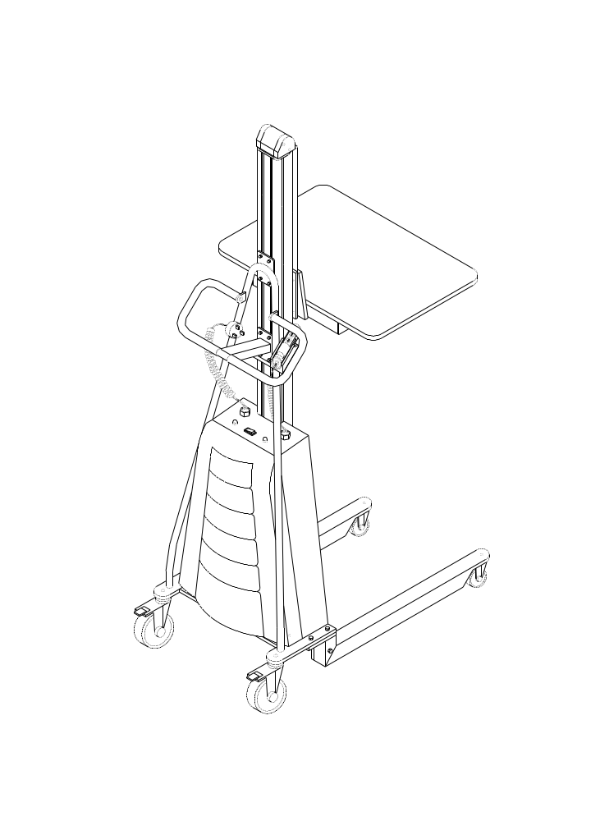

NOTE: The Owner/Operator must read carefully and understand all
the information presented here before operation.

CONTENT

- Dimension & Parameter Chart
- Part Name
- Warning
- Check Before Assembly
- Operation Guide
- Daily Maintenance & Periodic Inspection
- Trouble Shooting
- Explosive Graphics
- Chart of Parts
Thank you for your using this series of Elevators
This manual describes right operation method for ensuring safety and the right ways of maintenance, which prolongs the working life of the equipment. The operator must read carefully and understand all the information presented here.
This series of Electric Elevators are easy to handle with, safe and reliable, automatic and labor saving by small but high efficient and maintenance free cell power supplying, reliable small motorized chain driving , high performance panel control; movable electric push buttons control the movements of platform or other accessory upward or downward.
This series of Electric Elevators are mainly used for goods transition, elevation or piling, or taking off and transiting goods at some certain height on plain and smooth floor. The characteristics of pretty appearance, high intensity aluminum alloy pole, convenient and movable electric control, automatic and labor saving make the elevators be extensively used in. Especially, the configuration of several accessories and provision grade platform make the elevators be specially applied in transition of small column shaped working pieces, such as in packing material printing factories, super-markets, hotels and etc.

- Dimensions & Parameter Chart

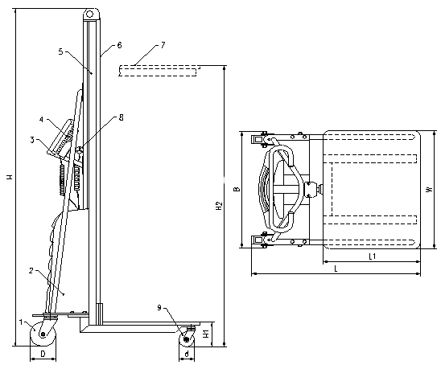

Model |  | E100R | E150R
Load Capacity | （Kg） | 150 | 150
Load Center C | （mm） | 235 | 235
Height min. H1 | （mm） | 130 | 130
Height max. H2 | （mm） | 1700 | 1500
Platform Size L1×W | （mm） | 475×605 | 475×605
Dimension L×W×H | （mm） | 825×605×2010 | 825×605×1810
Front Wheel d | （mm） | Φ75 | Φ75
Rear Wheel D | （mm） | Φ125 | Φ125
Net Weight | （Kg） | 67 | 64
Maintenance Free Cell |  | 24V | 24V

2. Part Name
- Rear Wheel 2. Electric Control of Transmission Box
3. Handrails 4. Movable Handy Panel
5. Aluminum Alloy Pole 6. Safety Belt
7. Platform (Various Accessories) 8. Socket for Charger
9. Front Wheel

3. Warning
- Use only on plain and smooth floor.
- Don’t overload, ensure load uniformity. Pay special attention when heavily loaded.
- Buzzer beeps to alarm cell low, charge in time or the cell shall be damaged.
- Ensure that the input voltage of the charger complies with local power net voltage.
- Not to contact chain or other moving parts.
- Not to carry out long hours of continuous work under heavy duty, lest troubles from over heated of motor and panel.
- The working life of the elevator shall be greatly prolonged when working under 0.7 times of the maximum nominal load.
- Keep the electric control commission box closed before operation.

4. Check before Assembly
E Series of single pole electric elevator is delivered in box with dis-assembled parts, and before exit factory, the product is adjusted. Please follow the following regulations to assemble and inspect the product before putting into use.
- Ensure the parts received are complete, in good condition and appearance free from any damage.
- Connect fast two pieces of front wheel forks (45) by bolts (43 and (46) to the supports of electric box (3) separately.
- Connect fast the fixed fork (27) by bolt (28) to safety belt (23), downward/upward bearing seat (35) separately, without loosening and ensure the safety belt is totally clamped firmly.
- Switch (5) power ON without load, (Buzzer may beep, switch off/on again, beep stops); operate the hand panel (16), platform (26) climbs smoothly up to the height maximum, keeps still, and then descends to the lowest position. The total commission makes no abnormal sound.
- Repeat the afore mentioned operation under rated load, the platform shall climb smoothly to the height maximum, stop without slipping, or descend smoothly to the lowest position and stop then without abnormal sound.
- The maintenance–free cell, which is provided together with the elevator, has been initially charged full before exit plant. Provided the interval from exit plant is relatively long, the cell may be no more full. Hence, for the first time heavy load climbing when buzzer beeps, it is necessary to charge again before reuse.

5. Operation Guide
1) Elevator: Operation of Transition, Loading and Unloading.
  - Lock truckles before goods loading and unloading at any height.
  - Take care of load uniformity when load and unload; deflected load is always not appreciated.
  - Mention not to loose equilibrium from one-sided unloading lest dangerous occurrences.
  - When it is needed to move the elevator with unfinished unloading, take care of the uniformity of the gods still needed to be unloaded.
  - Lower the platform to the lowest position when the loaded elevator is to move, sa as to ensure safety.

- Elevator: Operation of Climbing and Descending
  - Take care to stop at a right spot and ensure needed operation space when the elevator is to pile or take off goods for some height.
  - Lock the wheels, and switch power on.
  - Press on the UP button on the panel, the platform climbs smoothly to the needed height, and then release the button, the platform keeps still and shall no slip down. The movable hand control panel is convenient for the operator to observe and operate on different positions.
  - Strictly follow the regulations (1.1, 1.3, 1.4) to operate the elevator when goods raised up to the needed height for unloading or piling.
  - Strictly follow the regulations (1.1, 1.2, 1.5) to operate the elevator when taking off goods from racket.
  - When finishing unloading at some height, press the SOWN button for the platform descending smoothly; and the DOWN button can be released at any height needed while the platform shall stop descending for the elevator to perform a new job at same spot but different height.
  - The elevator is designed to possess the function of overload protection. Whenever the load surpassed 25% of rated capacity, the platform shall not be elevated, the elevator shall not be able to carry out the jobs of up-climbing, down-descending and vehicle transition.
  - The elevator is designed to possess the function of low power protection. Should the cell power is not sufficient for jobs during loaded climbing and descending, the buzzer beeps for 50 seconds alarm continuously and then cut off automatically the power circuit with indication light up (operator shall lower the platform to the lowest position during this period); the elevator is protected and the operation of climbing or descending is invalid even if the power is still connected.

3) Cell
3.1 High performance petty maintenance-free sealed acidic-lead storage cell is selected to power the elevator. It is characterized by low discharge ability, safe, easy mounting and change=over, and can be used under the ambient temperature range o f -15ºC~50ºC.
3.2 The working life of the cell is greatly depends on the right use. The working life of the cell shall be greatly shortened when repeatedly used at the condition of low voltage, and even burn the control element. Considering of this, the elevator is designed with the function of low voltage protection in the part of electric control. During the elevator is operating under low voltage for up-climbing or down-descending, the buzzer shall beep for 50 seconds continuously and then cut off the power supply. The operator shall charge the cell in time.

- Charger
  - High performance charger is provided together with the elevator, so that the cell can be chares at any handy power terminal. Be sure the voltage of local power net is as needed by the inlet voltage of the charger.
  - When charging with switch off elevator power, connect charger source pin and power terminal socket, the red indicator of source power of the charger is lit up, while the charging status green indicator is lit, that means the cell is tin the status of charging; and when the green indicator faded, that means the cell is charged full. Generally, the charging period takes 10~12 hours.
  - Shall the charged cell show low voltage status during heavy duty job, probably the cell is damaged or the charger is in trouble.

- Safety Belt
  - Safety belt is a safety device provided for preventing the transmission chain to break suddenly and that may cause equipment damaging. The device makes the elevator possess the characteristics of safe and reliable.

6. Daily Maintenance & Periodic Inspection
- Check if right every day for each status indication, including the smoothness and stability of platform up-climbing and down-descending.
- Check once a month if any deformation, connection loosening, wearing and abnormal sound for connecting bolts, wheels, rolling bearing, transmission chain, structure parts and moving parts.
- Check once a month the jiggling, wearing, lubricating, and loosening for chain, sprocket wheel, chain-trolley and connecting bolts inner transmission box, grease in time, as well.
- Once each three months check control panel, charger, cell and electric control wiring if any loosening inner transmission box and the inner box cleaning.
- Check each month the bending and deforming status of the pole, and if the flexible and smooth for the safety belt protruding and retrieving.

7. Trouble Shooting
No. | Description | Cause | Treatment
1 | Power on, press UP button, platform not climbing up. | 1.Power switch damage | Check and changeover
1 | Power on, press UP button, platform not climbing up. | 2.Wire off | Check and connect
1 | Power on, press UP button, platform not climbing up. | 3.Cell dead or damaged | Charge of change
1 | Power on, press UP button, platform not climbing up. | 4.Button fail or wire off | Check and changeover
1 | Power on, press UP button, platform not climbing up. | 5.Panel fuse burnt | Changeover
1 | Power on, press UP button, platform not climbing up. | 6.Motor damaged | Check or changeover
1 | Power on, press UP button, platform not climbing up. | 7.Overload | Partial unloading
1 | Power on, press UP button, platform not climbing up. | 8.Lowest Position traveling switch fail | Check or changeover
2 | Press UP button, climbing slowly or not climbing up | 1.Cell low or over discharged | Charge in time
2 | Press UP button, climbing slowly or not climbing up | 2.Motor trouble, RPM lowered | Check or changeover
2 | Press UP button, climbing slowly or not climbing up | 3.Panel adjustment fail | Re-adjust panel
3 | Platform can not climb to the height max. | 1.Barrier inner guiding rail | Clear away barrier and lubricating
4 | Platform climbed to the height max but fail to descending | 1.DOWN button fail | Check or changeover
4 | Platform climbed to the height max but fail to descending | 2.Travelling switch inner panel fail | Check or changeover
4 | Platform climbed to the height max but fail to descending | 3.Panel damage | Check or changeover
4 | Platform climbed to the height max but fail to descending | 4.Safety belt fail, not working | Check or changeover
5 | Safety belt fails to protruding or retrieving | 1.Ratcher structure of the device retrieving fail | Check or changeover
5 | Safety belt fails to protruding or retrieving | 2.Wrest spring inner device damage | Check or changeover
6 | Cell charged, platform climbing slowly or can not climbing up | 1.Insufficient charging | Re-charge
6 |  | 2.Cell damage | Change new cell
6 |  | 3.Charger fail | Check or changeover the charger
7 | Obvious low voltage but buzzer not to beep | 1.Wire off or buzzer fail | Check or changeover
7 | Obvious low voltage but buzzer not to beep | 2.Buzzer circuit damage | Check or changeover
8 | Abnormal sound from platform up/down transmission | 1.Chain elongated | Adjust to proper
8 | Abnormal sound from platform up/down transmission | 2.Sprocket loosening or shift | Check, adjust or fix
8 | Abnormal sound from platform up/down transmission | 3.Sprocket wheel damage | Check or changeover
8 | Abnormal sound from platform up/down transmission | 4.Other commissioning part worn out, deformation | Check or changeover

8. Diagram
(1)Wiring diagram of Electric Control
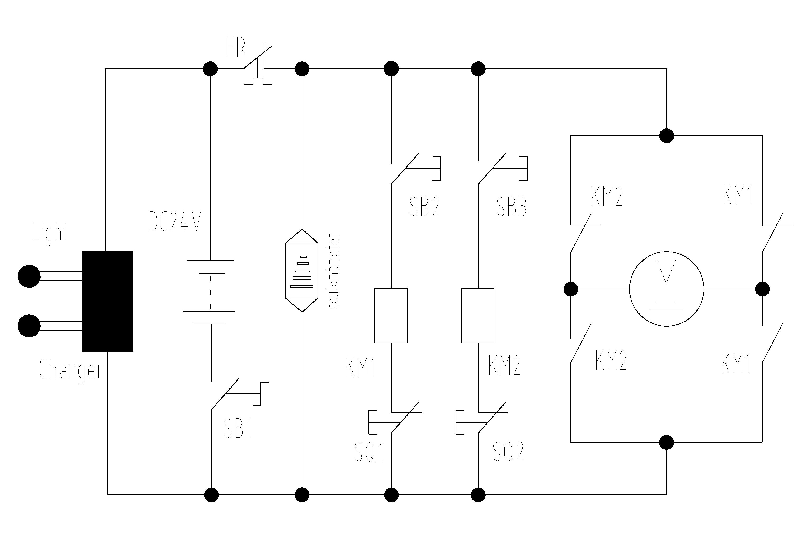

FR | Thermal cutoff | KM1 | Up Contactor
SB1 | Power Supply Switch | KM2 | Down Contactor
SB2 | Up Limit Switch | SQ1 | Up Limit Switch
SB3 | Down Limit Switch | SQ2 | Down Limit Switch

(2) Sketch Map of Electric Panel
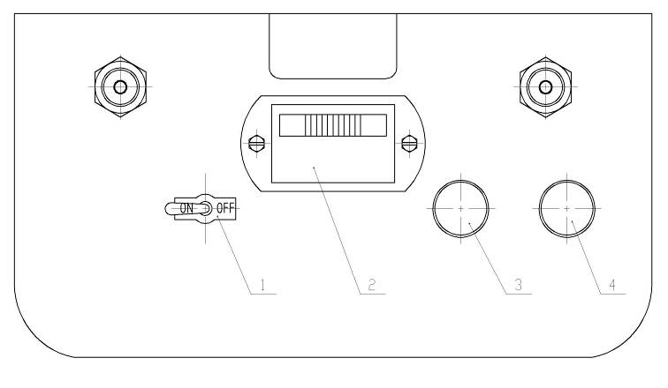

1 | Power Supply Switch
2 | Power Indication
3 | Charging Status(charged)
4 | Charging Status(charging)

9. Exploded View
- E100R/ E150R Single Pole Electric Elevator
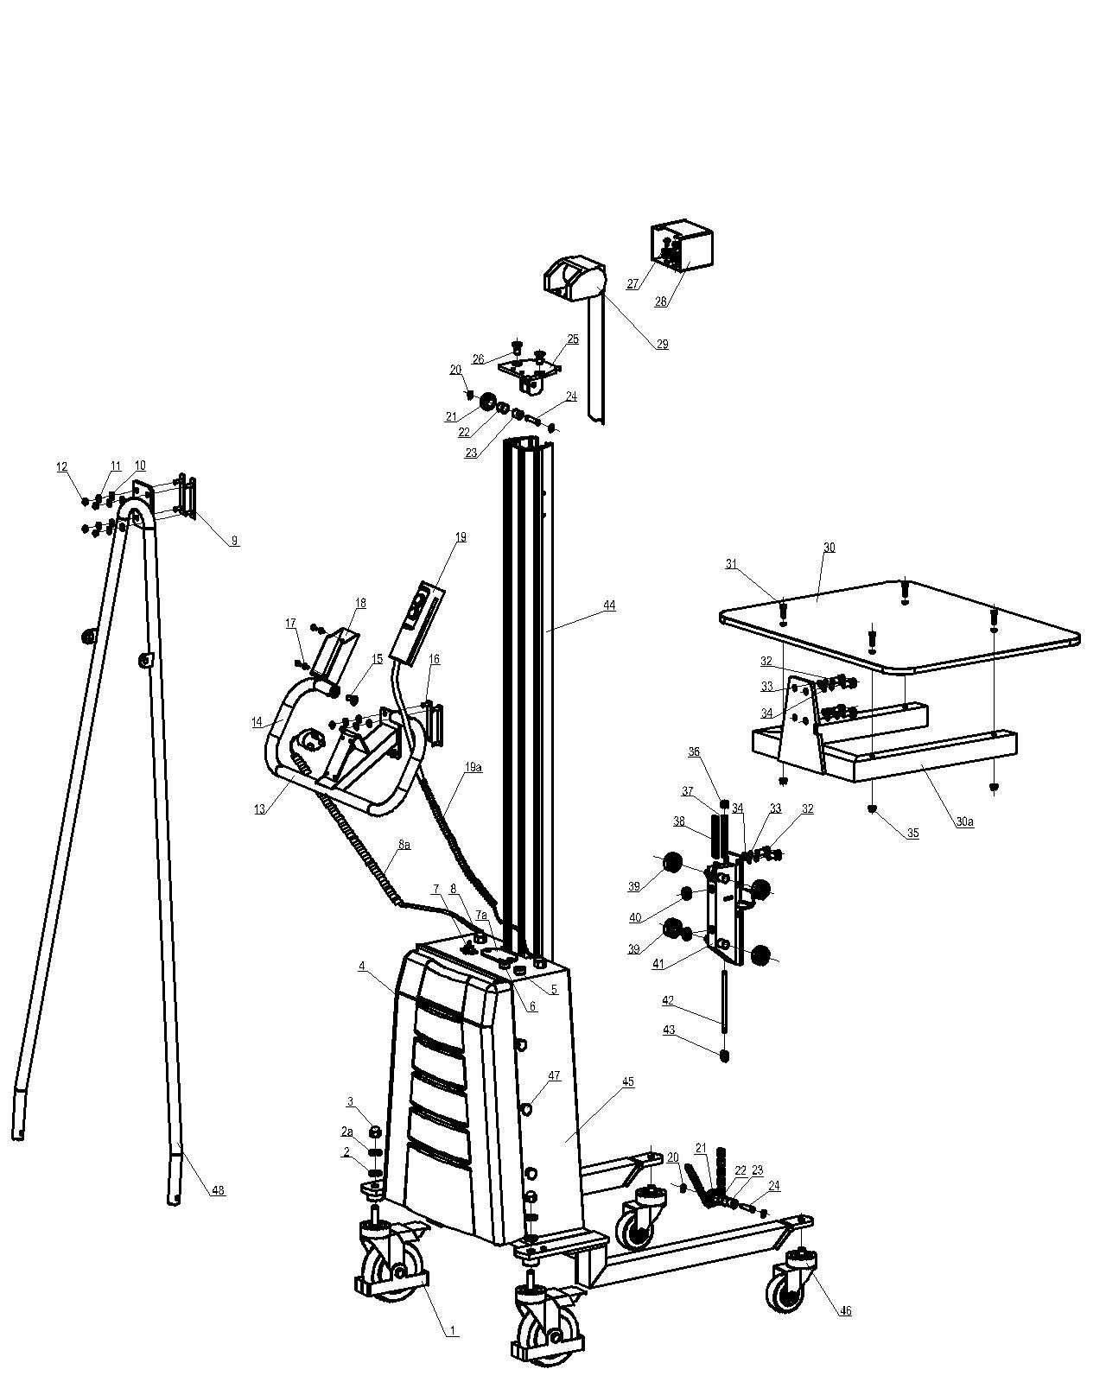

- Electric Box of E100R/ E150R
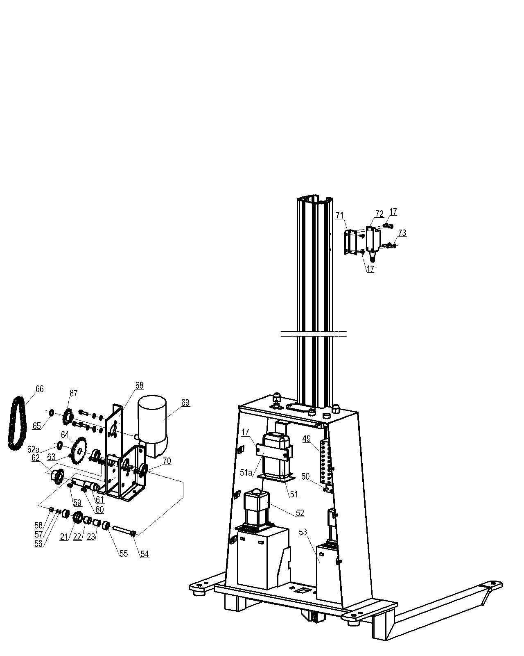

- Chart of Parts
(1) E100R/ E150R Single Pole Electric Elevator
No#. | Part Description | Q'tity | No#. | Part Description | Q'tity
1 | Rear Swivel Castor Unit（5''） | 2 | 37 | Load Chain Buffer Spring | 1
2 | Plain Washer 12 | 2 | 38 | Load Chain
2a | Spring Washer 12 | 2 | 39 | Ball Bearing 6202 | 4
3 | HEX DOMED CAP NUT M12 | 2 | 40 | Guide Wheel | 2
4 | Electric Box Cover | 1 | 41 | Mounting Seat for Roller,Weld | 1
5 | Charging Indicator-Green | 1 | 42 | Bolt,Load Chain End | 1
6 | Charging Indicator-Red | 1 | 43 | Load Chain Link | 6
7 | Toggle Switch | 1 | 44 | Aluminum .Mast | 1
7a | Battery Indicator | 1 | 45 | Main Frame,Weld | 1
8 | Wire fixing Nut | 2 | 46 | Front Swivel Castor Unit（3''） | 2
8a | Charger Adjustable Wire & Plut | 1 | 47 | Combination screw | 6
9 | Plate for Handrail | 2 | 48 | Supporting Handrail,Weld | 1
10 | Plain Washer 6 | 15 | 49 | Terminal block | 1
11 | Spring Washer 6 | 15 | 50 | Circuit Breaker-Automatic Reset | 1
12 | Hex Domed Cap Nut M6 | 8 | 51 | Charger | 1
13 | Handle,Weld | 1 | 51a | Fixing Plate for Charger | 1
14 | PU-Buffer | 2 | 52 | Contactor | 2
15 | The countersunk head screw M8X20 | 4 | 53 | Battery -12V12Ah | 2
16 | Mount Plate | 2 | 54 | Socket head cap screw M8X60 | 1
17 | The countersunk head screw M4X10 | 12 | 55 | Bushing | 2
18 | Control Handle Seat | 1 | 56 | Plain Washer 8 | 1
19 | Control Handle | 1 | 57 | Spring Washer 8 | 1
19a | Adjustable Wire for Control Handle | 1 | 58 | Nut M8 | 1
20 | Retaining Ring 8-Shaft | 4 | 59 | Flat key 6X6X10 | 1
21 | Load Chain Guide Wheel | 3 | 60 | Flat key 5X5X14 | 1
22 | Copper Bush 15X1 | 3 | 61 | Transmission Shaft | 1
23 | Spacer Tube | 3 | 62 | Sprocket Wheel-12 teeth（12齿） | 1
24 | Shaft-Load Chain Guide Wheel | 2 | 62a | Retaining Ring - 15-Shaft | 1
25 | Top Block Cover | 1 | 63 | Stopper Screw M5X10 | 1
26 | The countersunk head screw M10X20 | 2 | 64 | Sprocket Wheel-23 teeth（23齿） | 1
27 | Socket head cap screw M6X10 | 4 | 65 | Retaining Ring 12-Shaft | 1
28 | Protection Steel Cover-Safety Belt | 1 | 66 | Transmission chain | 1
29 | Safety Belt Unit | 1 | 67 | Sprocket Wheel-13 teeth（13齿） | 1
30 | Platform | 1 | 68 | Reducer seat | 1
30a | Base Frame,Weld,Platform | 1 | 69 | Worm Gear Box assembly | 1
31 | Socket head cap screw M6X20 | 7 | 70 | Ball Bearing 6002 | 2
32 | Socket head cap screw M10X20 | 6 | 71 | Seat for Limit Switch | 2
33 | Spring Washer 10 | 6 | 72 | Limit Switch | 2
34 | Plain Washer 10 | 6 | 73 | Cross pan head screw M4X25 | 4
35 | Hex flange self-locking nut M6 | 4 | 74
36 | The hexagonal locking nut M8 | 2 | 75

