Instruction Manual

Drum Truck

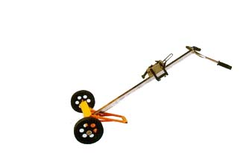

Note: The Owner/Operator must read carefully and understand
all the information presented here before operation.
THANK YOU FOR USING THIS DRUM TRUCK. FOR YOUR SAFETY AND CORRECT OPERATION, PLEASE CAREFULLY READ THIS INSTRUCTION BEFORE USING IT.

NOTE: All of the information reported herein is based on data available at the moment of printing. The factory reserves the right to modify its own products at any moment without notice and incurring in any sanction. So it is suggested to always verify possible updates.

- SPECIFICATION
Model | DE450
Capacity | 990lb
Drum Size | 30 or 55 gallon
Overall Size | 60”×24.4”×59”
Net Weight | 61.6lb
Wheel (Poly) Dia.×Width | 9.8”×2”

- ASSEMBLY & OPERATION
  - The pipe (Part No. 7) must be vertical on the pedestal (Part No.3) for using this drum truck rightly when assembling it.
(NOTE: Numerals refer to part list on reverse side of this manual.)
  - Please adjust the grip mouth height until it is 1cm higher than drum’ before using this drum truck.
  - Move the truck near the drum and pitch it. Lower the upper grip mouth until it reach the drum rim, then step on the truck body by foot and pull the handle to grip the drum rim tightly by lower grip mouth.
  - Go on stepping on the truck body and pull the handle closer to the people to lift the drum off the ground until the gravity center of drum locate between of the two wheels
  - Step on the truck body by foot and put up the handle slowly to land the ground safely after the truck arrived the destination, then pitch the truck and loosen the grip mouth to move the truck, and move foot away the truck.
  - Usually stand the truck body on the ground to keep the drum truck safely.
  - Add the lube into the active part of the grip assy. Usually , and ensure the bolt connecting strong

- EXPLODED VIEW & PART LIST

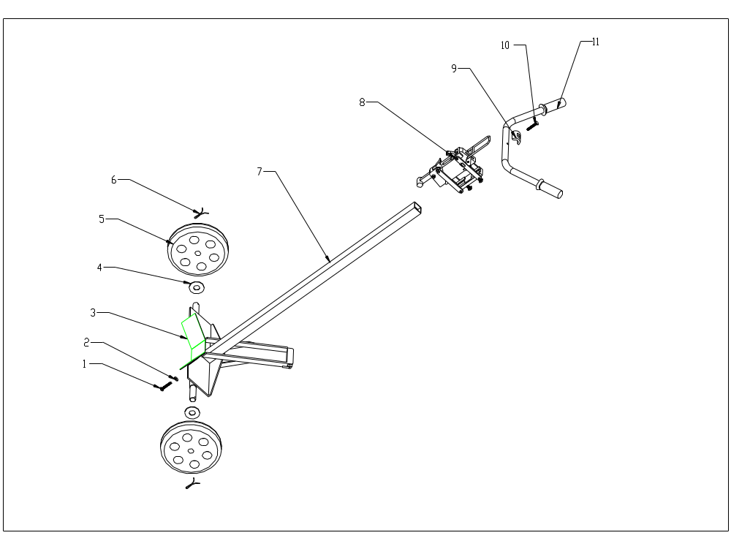

No. | Description | Qty | No. | Description | Qty
1 | Hex bolt, M0.4×1 | 2 | 7 | Pipe | 1
2 | Washer, ф0.4 | 2 | 8 | Grip assy. | 1
3 | Pedestal | 1 | 9 | Half-circle washer | 1
4 | Wheel, ф10×2 | 2 | 10 | Hex bolt, M10×50 | 1
5 | Washer, ф1 | 2 | 11 | Handle | 1
6 | Spring pin | 2

