Preface

Thank you for choosing Top CNC!
This instruction manual is your technical document explaining the proper use and safe operation of the TC-1325AC engraving machine. Please read it carefully and keep it for your records.
In order to receive optimum performance of the TC-1325AC and ensure the safety for the user, please carefully read this manual before installation to learn more about the safety precautions of the equipment, proper installation, operation parameters, troubleshooting diagnosis, and routine maintenance.

About safety identification
To prevent damage to the product and to prevent injury to yourself or others, please read the
following precautions carefully before using the device.
If operated improperly the user puts themselves and those around them at risk of moderate to
severe injuries.

Precautions
In order to use the machine safely and correctly, be sure to read this matter carefully before use.
The warning signs in this manual and equipment mean that if you do not comply with the relevant requirements and do not take appropriate measures, it may result in personal injury and equipment damage.

Requirements for equipment operator
The personnel who operate the equipment should be familiar with the steps and requirements for installation, debugging and commissioning of the equipment, as well as the corresponding measures for various emergencies that can occur. After familiarizing themselves with all safety features and operations contained within this manual the user can then safely operate the machine.

The operator should check the following on a daily basis:
1. Verify all safety switches are operational.
2. Clear work table of debris and scrap material.
3. Always be aware of your surroundings and ensure no other person is in the working area vicinity.
4. Do not wear gloves when operating the machine.
5. Keep a clean working area surrounding the machine.

Warning

- The TC-1325AC utilizes 220V 3ph voltage. When the equipment is connected to the power supply, the electric cabinet door and the electrical control box must not be opened during operation to avoid electrical shock.

- Ensure the machine is properly grounded and all electrical connections are secure.

- The equipment has been calibrated prior to shipment and it is prohibited for non-qualified personnel to make adjustments.

- Keep children and non-professionals away from the machine at all times.

- Take note of all warnings labels on the machine and familiarize yourself and those around the machine of their meanings.

- Only when you are familiar with all the safety instructions and regulations on the installation, commissioning, operation, maintenance, contained within this manual can a reliable guarantee for the safety and successful operation of this equipment be ensured.

Contents

Preface…………………………………………………………………………….1
Contents …………………………………………………………………………4
I. Product Inspection……………………………………………………….4
II. Machine Installation……………………………………………………4
III. Machine Operation…………………………………………………….9
IV. Equipment Maintenance.………………………………………….18
V. Fault Analysis and Troubleshooting………………………..….20
VI. Carving Techniques…………………………………………………..21
VII. Equipment Warranty details.……………………………………21
VIII. Warning………………………………………………………………….22
The contents of this manual are subject to change without notice.

- Product Inspection
The machine is strictly inspected and packaged before leaving the factory. Please check before use. Please contact your local dealer if there are any problems.

Please verify the following
1. No machine damage.
2. All machine accessories are included.
3. Machine model.
II. Machine Installation
Installation environment
1. Utilize a dry environment.
2. Finished level surface.
3. No electromagnetic interference.
4. Ambient temperature of 10 °C ~ 40 °C. If the ambient temperature is more than 40 °C above, please place in a well-ventilated place.
5. Verify Input voltage is 220V 3ph along with proper grounding.
6. If voltage is not stable a voltage regulator may be required.

Machine installation steps
- Remove the machine from its pallet and place in the desired working position. Install the base plates on the machine feet and level the machine using the adjustable feet. Then place the electrical control box on the left side of the machine.
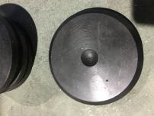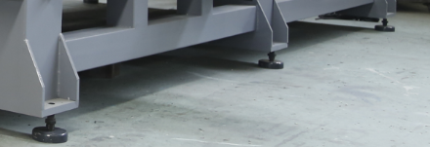

- Connect 220V power supply to the control box. There are two power supply, B for vacuum & dust collector, A for machine). After installing the power check to ensure the phase is correct.
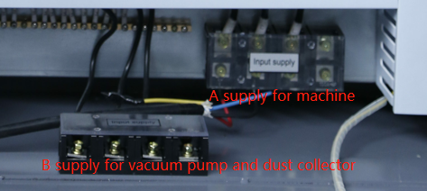

- Install the control system
- Remove the DSP handle and cable from inside the electrical cabinet.
- Connect the cable to the terminal board then to the handle.

(Note: Please refer to the CD operating system manual for details of DSP system operation)
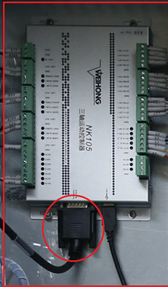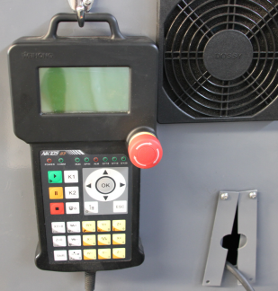

- Install Vacuum Pump
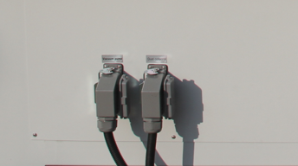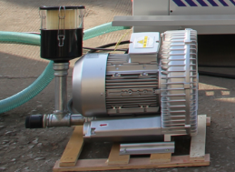

- Connect fittings to inlet of pump.
- Connect the additional fitting to the T connection.
- Install the filter.
- Connect the vacuum hose from the filter to the machine and secure with hose clamps.
- Remove electrical lid and connect electrical wires. Refer to wiring diagram on the inside of the lid for proper installation.
- Plug the cable into the electrical cabinet and supply power. Verify that air is being exhausted from the outlet of the pump. If not immediately disconnect the pump from the cabinet and change any two of the three connected live wires. BE SURE TO DISCONNECT POWER BEFORE ADJUSTING CONNECTIONS!

- To test the suction power of the vacuum pump, place a 100mm x 100mm piece of wood over the air inlet and if the board remains suctioned to the pump the suction is sufficient.
- Install sealing strip on the vacuum table. The area of the sealing strip should be the same as the size of material being cut.

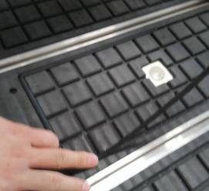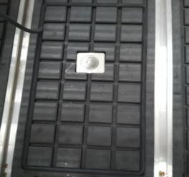

- Install the Dust collector
(Note: Before powering on, check whether the voltage is consistent)
1.Remove the dust collector from the package and install it according to the instructions of the dust collector.
2.Connect the dust collector to the machine connection.
3.Connect the other end of the power cord to dust collector motor.

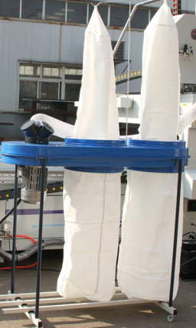

4. After power on, press the dust collector to check whether the motor rotates forward. If the inverter reverses, replace any two fire wires.

- Install air lines to water separator.

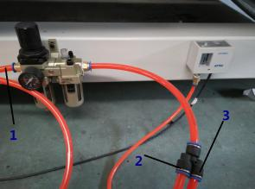
1. Supply line from air compressor 2. Connects to the filter. 3. Connects to the water separator on top of the machine.

- Install the tool block

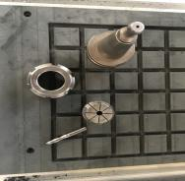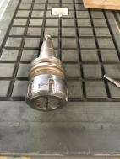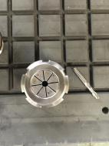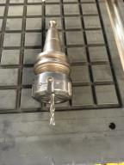

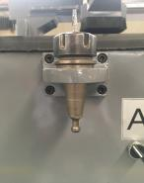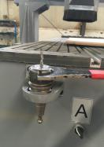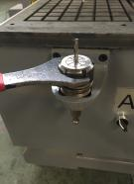
Place the tool in the tool holder, then change the router bit using a spanner wrench.

- Install auto lubrication pump
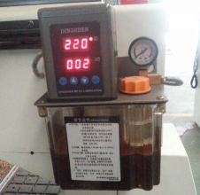

- Check the tool sensor
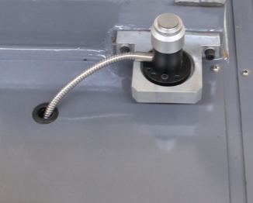

After completing the installation, it is recommended to place a piece of MDF board at 6~8mm thickness on the table face, then put your work piece on it. This creates a solid suction with the vacuum and also prevents debris from entering the vacuum.
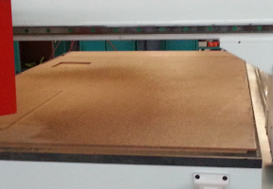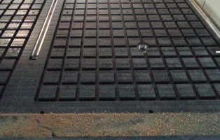

- Machine Operation

Before turn on the switch,pls press the Estop
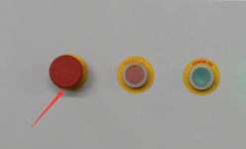

- Turn on the switch on control box door
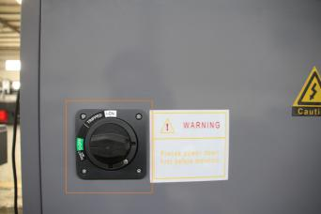
- Press Power On:
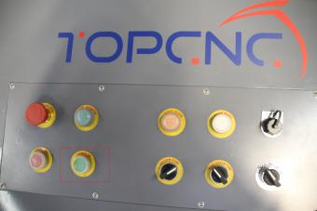

If the system alarm to Estop,pls release Estop,

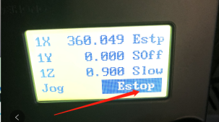

- System will alarm to ask Last is not Nc file, press OK
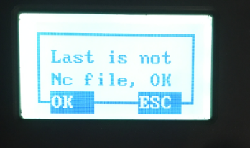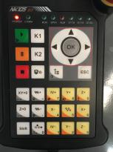

- System will alarm to ask machine back to REF point, please press OK to return home
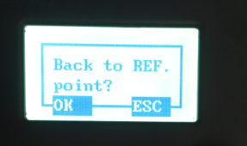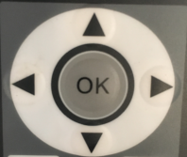

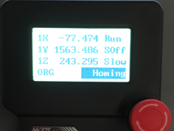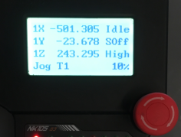

- Install the tools on magazine

Tip 1: Always check your tool to ensure it is in the proper holder prior to cutting.
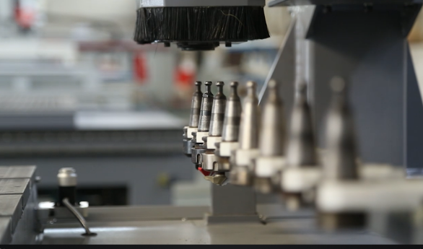

Tip 2: Be sure to support the tool by hand when manually changing to prevent damage.
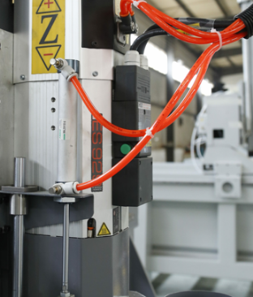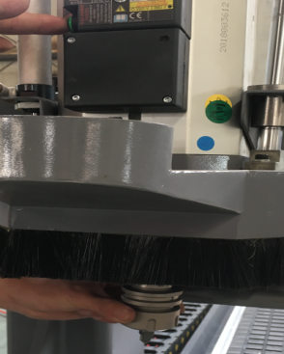

Tip 3: Be sure to verify the tool displayed on the DSP controller is in fact the correct desired cutting bit. If that tool is labeled Tool 1 then the holder for T1 in the tool holding station should be empty. See the picture.
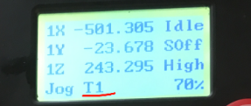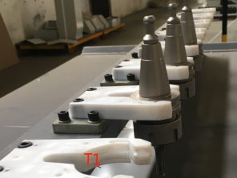

- Set the work piece coordinate:
First press X+, X-, Y+, Y-, move the spindle to desired work piece starting point.
- Press  and you will notice .

Press  to adjust the spindle from Jog to Stepping.


- Calibrate your tool.

Move the spindle up to the tool sensor 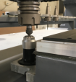 press and hold 

(make sure the tool contacts the tool sensor).

then press together
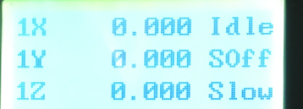.

All other parameters are set in our workshop. No need to adjust.
- Choose and run the program by first copying your file located on the USB to the DSP controller.
- Insert your U disk on the controller then press OK.
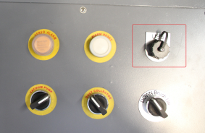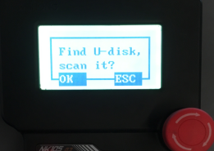
- Select up or down to find your file then press OK. press 3 to copy your files to control system then press OK.
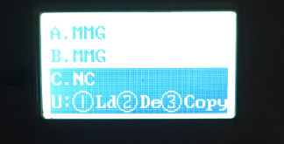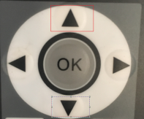
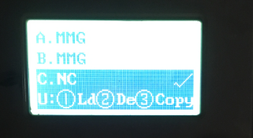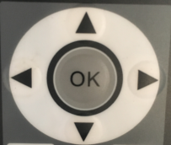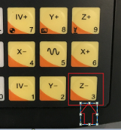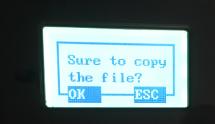

- Run the program
Press manual, choose local files, press OK, UP and down to select your files, then press OK to c
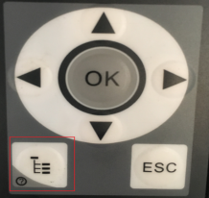
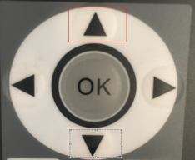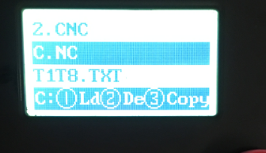
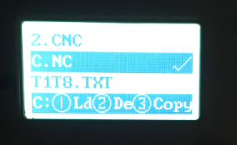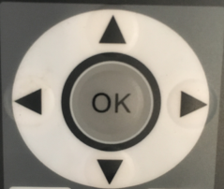

- If the file is right, please press 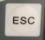 to the Main interface, then press to let the spindle up to its max Rotating speed, then press start your program.
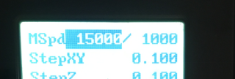

IV. Equipment maintenance
Do not change the machine or appliance without understanding or authorization, otherwise it may cause malfunction or injury! Turn off the main power supply when servicing. Always consult with your electrician when working with the machines supply voltage! Maintenance replacement parts must meet the specifications of the technical documentation. Please consult the manufacturer or dealer prior to replacing parts.

(1) The operator should develop proper habits of maintaining the equipment.
(2) Routine maintenance includes cleaning surrounding work area, spindle motor, work table, control cabinet, chuck, and nut of the spindle motor daily.
(3) Clean the spindle, X, Y, and Z-axis slide bearings, guide rails, gears, precision racks, and lubricate. Add lubricating oil if the lubricating oil can be evenly distributed on the transmission parts which will extend the lifespan of the machine. Check all wiring connection cables, and proximity switches to ensure secure connections are made. Make sure all fixing screws of servo motor and motor shaft in the three directions of X, Y, Z are tight.
(4) Check regularly if the emergency stop button is normal.
(5) Regularly clean the cooling ventilation system of the numerical control device. Always check if the cooling fans on the CNC device work properly. The inspection should be conducted once every six months or one quarter depending on the conditions of the workshop environment.
(6) Regularly monitor the grid voltage of the CNC system.
(7) Prevent dust from entering the CNC device, and ensure to remove any debris build up within the electrical cabinet using light air.
(8) It should be noted that CNC machine tools are not suitable for long term storage. The purchased machine should be put into production as soon as possible. If the CNC machine goes without use for a long time, the electronic components may collect moisture and the performance of the CNC machine will be reduced or damaged. Therefore, when the machine is idle for long periods of time, the CNC system should be regularly maintained and kept dry.
(9) Check guide rails and remove debris before operating and ensure proper lubrication.
(10) Make sure the servo motor tooth rack rail is kept clean and free from wood and dust.

Mechanical maintenance
New machines will have a break in period which is the tightness of mounting hardware of rails, motors, cover plates, etc. will become loosened. Please be sure to check the tightness of these fasteners regularly during the machines break in period. Typical break in periods estimate to one week of operation.

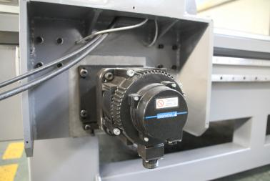
1. Transmission Reducer Adjustment:
(1) Open the two side covers of the y axis motors and remove then remove secondary covers.
(2) Loosen 4 orthogonal hex bolts and the 5th hex bolt which can be seen from the bottom opening of the reducer gear box. The gap can be adjusted by pushing hard to the direction of the rack. (Note: do not strike the object with the weight when adjusting.)
(3) Tighten all 5 hex bolts and replace both covers.
(4) Run the machine to test the alignment.

2. Cleaning
(1) Clean up the dust, dirt and dirt on the guide, rack, screw and so on in time so as not to affect the use of the machine
(2) After the removal of the dirt, the lubricating oil should be added. (Note: liquid lubricants less than 1500SC)
(3) The surface of the rack also needs to be cleaned regularly and coated with antirust or lubricating oil to prevent rust, generally half a month for a cycle.
(4) Check the tightness of the synchronous belt and adjust it in time. (Note: standard within 2mm of winding degree)
(5) Machine with a refueling device, oil marking: N32 mechanical oil.

Maintenance list
Sequence number | Component | Content | Cycle / Time
1 | Air-cooling spindle | Ensure spindle appearance is neat running smoothly/quietly. | everyday
2 | Air-cooling spindle | If abnormal spindle sound or high spindle temperature please turn off your air and check to ensure all air lines are free of debris. | everyday
3 | Vacuum/Air/Debris Lines | Ensure all air lines, vacuum lines, and debris lines are free from blockage. | everyday
4 | The indicator light / warning light / control button | The indicator light / warning light / control button is checked to be normal; | everyday
5 | lubricating system | Check the lubricating oil levels and ensure there is sufficient fluid. | everyday
6 | electric cabinet | Check to ensure all cooling fans for the electrical cabinet are free of debris and working properly. | everyday
7 | Line guide rail lubricating | Line guide rail lubricating sliding surface clean, no rust, no damage, stable operation, on-time lubrication. | everyday
8 | urgent stop switch | Ensure both E-stop buttons are functioning properly. | everyday
9 | The synchronizing belt | regularly checks the tightness of the synchronous belt and adjusts in time. (Note: standard within 2mm of winding degree) | 240hours
10 | Chiller | If the fan runs normally, the flow is smooth and the water level of the cooling water is normal. | everyday

3. Electrical Maintenance
(1) Clean debris from motors, drivers, inverter, in a timely manner.
(2) Regularly check the firmness of the line contact and the use of the wiring.

V. Simple Fault Analysis and Troubleshooting
Common Faults | Fault Causes | Method of exclusion
After starting the machine, when the zero-return command is executed, the motor moves in the opposite direction | The control system sends out an error signal | Power off and restart the machine to run again
 | Motor electrode wiring error | Adjust the X, Y axis motor lines  Change the direction of operation
Poor vacuum suction of workpiece | Inlet ventilation is blocked | Check inlet lines and remove debris
Poor vacuum suction of workpiece | Leakage of sealant causing air leakage | Check and replace the strip
Poor vacuum suction of workpiece | Uneven work | Replace flat work
Using a large knife to sculpt when starting the spindle is noisy and resonant | Rotor shaft and jacket friction | Stop the spindle to adjust the gap between the rotor and the sheath
 | Improper tool balance, handle is not correct | Re-adjust the tool
Limit switch not working | Broken switch or broken switch line | Change the switch and check the line

Common Fault | Causes | Judgment method | Solution
Spindle stall | 1. The line is short-circuited or blocked  2. The inverter shows abnormal output  3. Spindle failure | 1. Use a multimeter to measure the continuity of the circuit  2. Look at the inverter display is abnormal  Measure the output terminal voltage  3. Whether the inverter is no-load normal, abnormal load | 1. Replace the spindle three-wire  2. Adjust the inverter parameters  Replace the inverter  3. Replace or repair the spindle
Machine axis or multi axis does not move | 1. Input and output lines are abnormal  2. Drive failure  3. Poor connection between motor and reducer | 1. Use a multimeter to measure the continuity of the circuit  2. See if the indicator light flashes; two drivers swap test  3. Can see the motor rotation but the machine does not move | 1. Change the connection signal line  2. Replace the drive  3. Fastening screws
Stepper motor malfunction | 1. Driver overheat  2. Poor connection between motor and reducer  3. No ground wire or poor conductivity | 1. The driver has problems after working for a long time  2. Can see the motor turns but the machine does not move  3. Check connection between ground cable and the machine | 1. Replace the drive  2. Fasten screws  3. Secure the ground

VI. Simple carving techniques
- Wood carving
Solid wood is the main raw material for modern homes, so there are many patterns in wood carving, different materials have certain differences in the method of engraving, here are some simple engraving techniques for reference only:
- Wood with relatively loose texture, coarse wood wool, and strong toughness should adopt horizontal broken wire engraving. When carving, the feed speed should be slow and gradually accelerate.
- For harder wood，when use small knife engraving should use slow speed to make the travel space and then gradually speed up carving.

VII. Equipment warranty details (Please pay attention)
- the key parts warranty cycle
Calculated from the time the machine leaves the factory. Under the condition that the machine is working normally for 8 hours/day, our company undertakes the warranty for key parts of the machine. The specific warranty time is as follows:
- Purchase this engraving machine, bed, drive, frequency converter, spindle (one-year warranty for spindle produced by this company, half year warranty for outsourced spindle), screw, guide rail, drive motor, reducer, control system main part (limited Genuine), equipment cable, the above accessories can be a one-year warranty;
(2) Control system data line (limited to original), cabinet board (limited to original), light switch, above accessories can get 3 months warranty;
(3) Other vulnerable parts are not warranted.
2. Please keep A card after purchase, and return B card within ten days, otherwise the company will only provide paid warranty.
3. Please mark (or specify) the product number.
4. Because of the natural forces and artificial damage, due to improper repair, resulting in the normal use of the machine, because the abuse beyond the scope of use, the loss of buyer personnel, improper operation, resulting in the use of the machine cannot be used, the company will only provide paid services.

VII. Warning
I. Without the company's permission for private demolition, all the consequences of the private change of the machine caused by the customer at the same time, at the same time the company terminated all services after sale.
II. The company will only provide paid service if the return receipt is returned to the company and it proves that you have carefully read this manual, the fault caused by improper repair and repair, and the wrong use beyond the scope of use.
III. The customer is responsible for the damage caused by the lack of phase in the other power equipment.
IV. If the machine smokes, emits odors, noise, etc., please cut off the power immediately and do not use it.
As shown in Figure 6, ensure that the machine is reliably grounded.
V. Do not use corrosive liquids to clean machine parts and keyboards.
VI. According to different points carved material and engraving depth to select the appropriate tool and set the appropriate feed rate (the tool should be manually rotated after the spindle to observe the tool is vertical and concentric if not vertical concentric should re-install or replace the tool).
VII. Rotate the tool before performing Z-axis positioning and engraving output.
VIII. Before each engraving operation, please be sure to check whether the spindle cooling water circulation is smooth, so as not to burn out the spindle (cooling water should be replaced in time when the spindle temperature is high).
IX. Don't destroy or replace the original power cord arbitrarily. Do not make the power cord excessively bent, pulled, bundled, or pressed under heavy objects.
X. Do not touch the tool and the spindle part by hand during the working process of the machine.
XI. The machine cannot penetrate the liquid, fell into the metal parts. After each engraving, the machine should be cleaned in time to remove chips and dust. Lubricate the screws, bars, guide rails, and racks regularly. keyboard.

